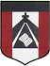
ESCUELA NUESTRA SEÑORA DEL VALLE

Estimadas familias y queridos chicos: ¡Buena semana! ¡Seguimos trabajando !
Link diccionario: https://www.wordreference.com/es/translation.asp?tranword=a

¡Saludos ! Miss Marian mfrontera@institutonsvallecba.edu.ar

May 18th, 19th and 20th 4th grade
HELLO !! How are you dear children ? ____________________

- Revision
- School objects:
Let´s play ! a- https://agendaweb.org/exercises/vocabulary/school/objects-1.htm
b- https://agendaweb.org/exercises/vocabulary/school/multiple-1.htm
c- https://agendaweb.org/exercises/vocabulary/school/multiple-2.htm

- Free time activities: Watch https://youtu.be/aNvH0dRQfTM

B.Watch the presentation
https://docs.google.com/presentation/d/1vDxUjr4GOFy_KNYWBbURDwUwVt0vMaqknPWwXkl5KPk/edit?usp=sharing
Pupil's book pages 11 and 12 / Activity book pages 9 and 10

C. What does she like doing in her free time ? Write sentences using”She likes + verb ing”
( escribe oraciones sobre lo que le gusta hacer en su tiempo libre : She likes y el verbo terminado en “ing”. Te podés ayudar con el Activity book page 70, tu cuaderno o la presentación de diapositivas )

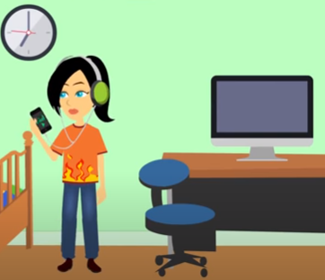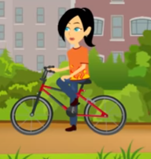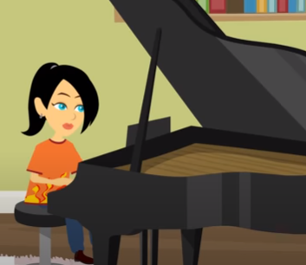

1- ___________________________________________________
2- ___________________________________________________
3- ____________________________________________________

What does he like doing in his free time ? Write sentences using He likes +verb ing
( escribir oraciones contando lo que le gusta hacer “ He likes + el verbo terminado en “ ing “ )
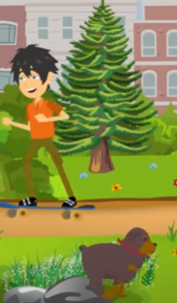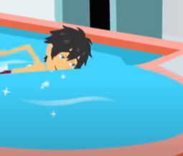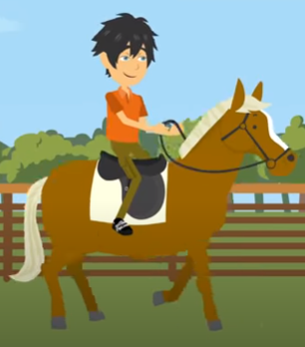

4- __________________________________________________
5- __________________________________________________
6. _________________________________________________

D. Draw or stick pictures ( dibujar o pegar figuras ilustrando la oración )
- She likes chatting online.
- She doesn't like playing the guitar.
- He likes playing football.
- He doesn't like riding a scooter.

1 | 2 | 3 | 4

E. Write the sentences ( escribe oraciones usando He likes…. He doesn't like… She likes …. She doesn't like + la acción terminada en “ing “ . Te podés ayudar con el Activity book page 70 )

- 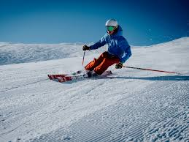 _________ _____________ ________________

- ____________ _____________ __________ __________

- 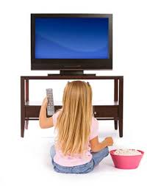 __________ _______________ _______________

- ________ _____________ ___________ _____________

Bye, bye !! Miss Marian

