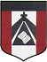
ESCUELA NUESTRA SEÑORA DEL VALLE
4th grade
October 5th , 6th and 7th

Hello children ! ________________
How are you ? ________________
What’s the weather like today ? ____________________________

- Revision Transport: Watch https://youtu.be/QxoqW84ec-M

- Transport: Play https://learnenglishkids.britishcouncil.org/es/node/18106

- Watchhttps://www.loom.com/share/cf918b2a19334b9c8fd938751b3fb969

- Watch https://docs.google.com/presentation/d/1UncJBfWZ86dtPi_3gscMYCFu3mH-xfZhhPu8gacLRj0/edit?usp=sharing
Pupil’s book pages 36 and 37 / Activity book pages 30 and 31

- Check your answers https://docs.google.com/presentation/d/1fxi6fFYdOnR1ML8KJthGXG0mSD7qzR--zXgULj7sVvg/edit?usp=sharing

- Transport

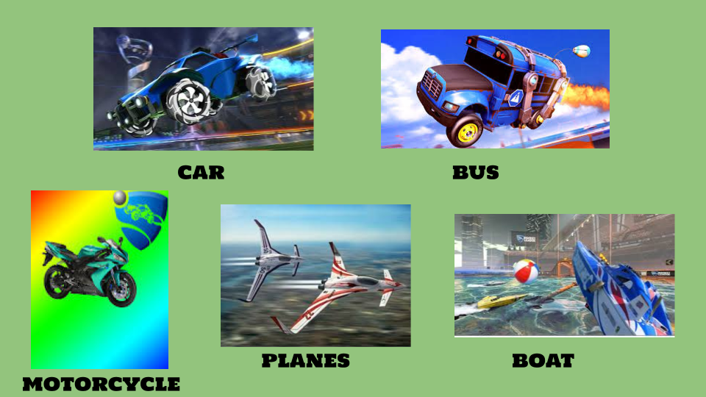
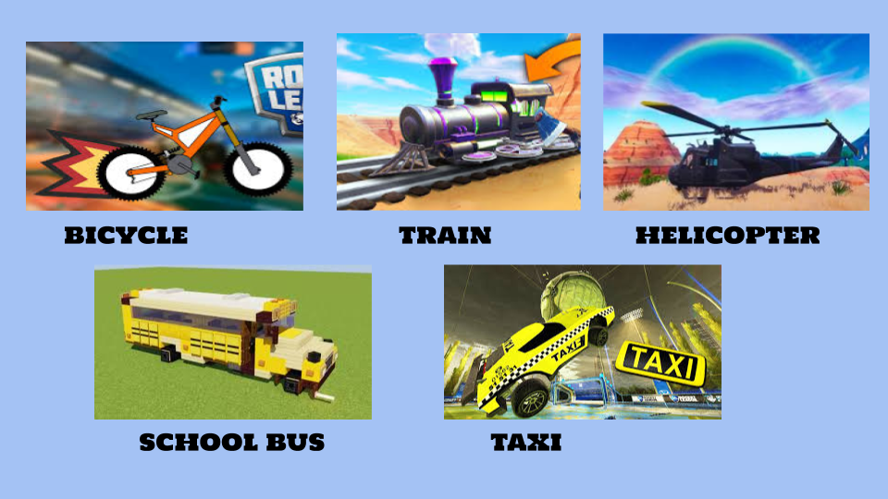

- He / She
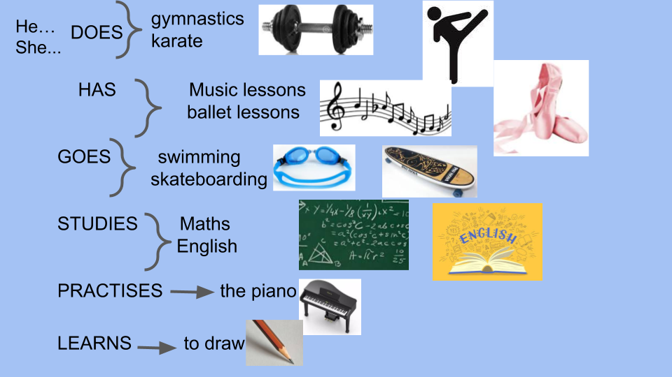

- Complete ( Escribí las frases del recuadro bajo el verbo correspondiente.Te podés ayudar con el activity book page 71)

the piano / ballet lessons / karate / swimming / music lessons / to a party / skateboarding / English / gymnastics / to school / Maths / to draw / to the park /

GO | HAVE | LEARN
PRACTISE | DO | STUDY

- Write the time

- It’s half past eleven __11:30__
- It’s twelve o’clock ________
- It’s half past twelve _______
- It’s half past three _________
- It’s one o’clock _________
- It’s half past six ________

Bye, bye !

Miss Marian

