Wednesday, March 18th 4th grade

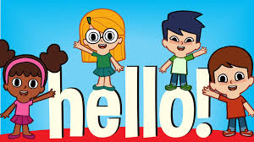

- Answer about yourself ( responder sobre sobre vos mismo )

- Hello! _______________________________________________

- How are you ? ________________________________________

- What’s your name ? ____________________________________

- How old are you ? ______________________________________

- What’s your favourite colour ? _____________________________

_____________________________________________________

- What’s your lucky number ? ______________________________

_____________________________________________________

- Goodbye ! ____________________________________________

B) Watch the video “Days of the Week Song for Kids “ ( mirar el video )

C) Write them in order ( escribirlos en orden )

- _________________________

- _________________________

- _________________________

- _________________________

- _________________________

- _________________________

- _________________________

D) Write the day you have the following subjects : ( escribir el/los día/s en el que tienes las siguientes materias )

- Religion ___________________________________
- English ____________________________________
- Music _____________________________________
- Art ________________________________________
- Computer Studies ___________________________

Congratulations on your effort !!!

(recordar copiar o imprimir y pegar en el cuaderno y enviar a

mfrontera@institutonsvallecba.edu.ar )

