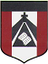
ESCUELA NUESTRA SEÑORA DEL VALLE

Queridos chicos y estimadas familias: Hoy comenzamos la unidad 5 relacionada a la “Ropa”. Vamos a aprender a describir lo que estamos usando e identificar lo que están usando las otras personas.
( Recordar al entregar las tareas, escribir en el asunto: nombre/ grado y fecha a la que corresponde el trabajo )
¡Felicitaciones por el esfuerzo que siguen realizando !
¡Que tengan una muy buena semana ! Saludos Miss Marian

October 19th , 20th and 21st 3rd grade

- Revision in / on / under : Play https://www.educaplay.com/learning-resources/6761002-prepositions_memotest.html

- Revision in / on / under :Play https://www.educaplay.com/learning-resources/6819927-preposition_of_place_kids_2.html

- Revision Pets/ House / Prepositions ( No aprendimos la 5: behind = atrás ) https://www.educaplay.com/learning-resources/6838544-preps_furniture_rooms_pets.html

- Revision Parts of the house: Play https://www.educaplay.com/learning-resources/7116884-house.html

- Watch https://www.loom.com/share/8016019354564857b9eaf808054c6589?from_recorder=1

- UNIT 5: Clothes
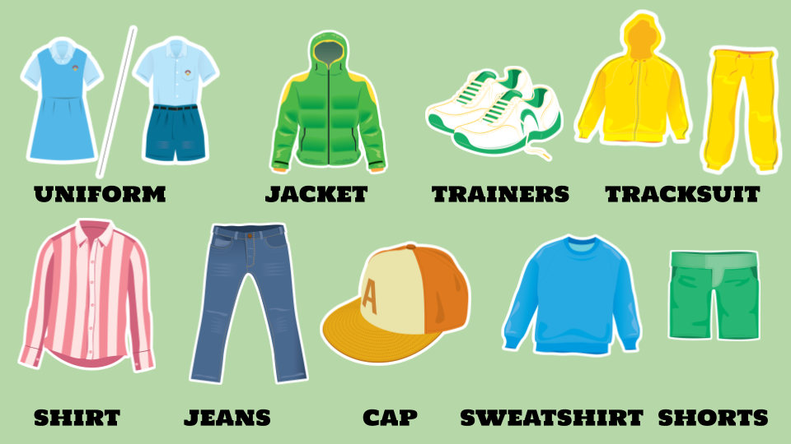

- What are you wearing ?

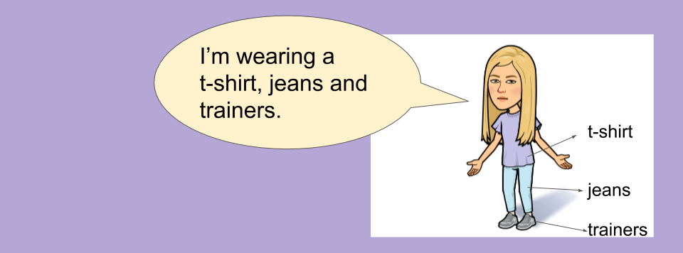

- Watch https://docs.google.com/presentation/d/1gud4GrmMOkfFM46mXsIpfbdNWgAYIIFyiQ_zWYJHsUU/edit?usp=sharing
Pupil’s book pages 42 and 43 / Activity book pages 36 and 37

- Check your answers https://docs.google.com/presentation/d/1sKVqbojOzc2LsB8b7LGhYLmhS3XB-9XkZltdeamgWNI/edit?usp=sharing

- Write “Yes” or “ “No” ( de acuerdo a si estás usando en este momento esta ropa o no )

- I am wearing a tracksuit. _________
- I’m wearing jeans. ________
- I’m wearing a t-shirt. _______
- I’m wearing trainers. ________
- I’m wearing a sweatshirt. ________
- I'm wearing a uniform. _________
- I’m wearing a jacket. _________
- I’m wearing a cap. ________
- I’m wearing a shirt. ________

Bye, bye !

Miss Marian

