ESCUELA NUESTRA SEÑORA DEL VALLE

October 19th, 20th and 21st 5th grade

Hello dear children !

How are you ? ____________________

- Clothes: Watch https://youtu.be/PKOVLKo3Z9M

- Numbers 1 to 100: Play https://es.educaplay.com/recursos-educativos/7005638-numbers_to_100.html

- Numbers 1 to 1000 : Watch https://drive.google.com/file/d/16NAl8jhXB7tYvxeq8LQtytxRWfaGSiGQ/view?usp=sharing

- Numbers 1 to 1000
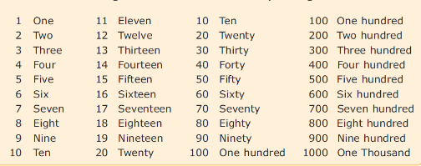
Examples : 91 ninety-one
140 one hundred and forty
360 three hundred and sixty

Write the numbers :
- 84 _______________________
- 200 ______________________
- 53 _______________________
- 170 ______________________
- 1000 _____________________

- This / That / These / Those : Watch https://drive.google.com/file/d/1zoIJck-1vDtAoUqjVmr3Xbk3U7qyl5mr/view?usp=sharing

- Clothes / this / that / these / those/ Numbers :Watch https://www.loom.com/share/ac1bb636723e43b0bdb234a364e61db8?from_recorder=1

- How much / Adjectives / too : Watch https://www.loom.com/share/db831b386b3c417bb546ae25019c1a6d?from_recorder=1

- Pounds

- How much is / are … ?
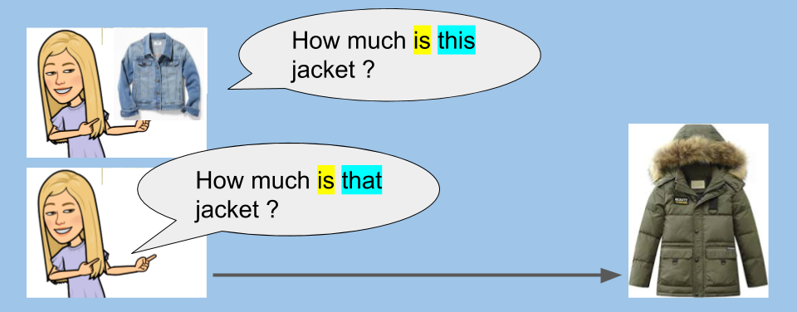
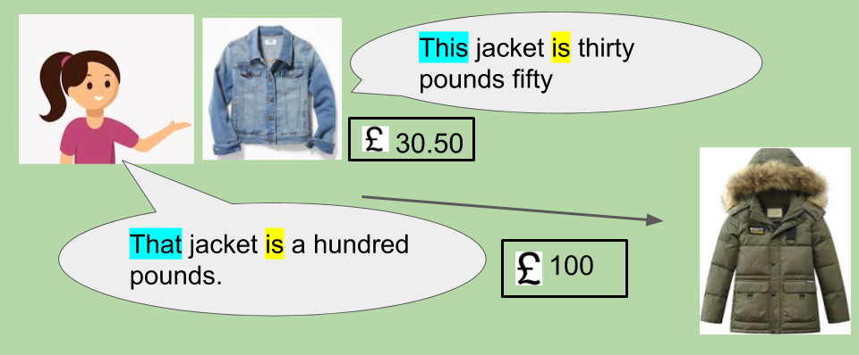
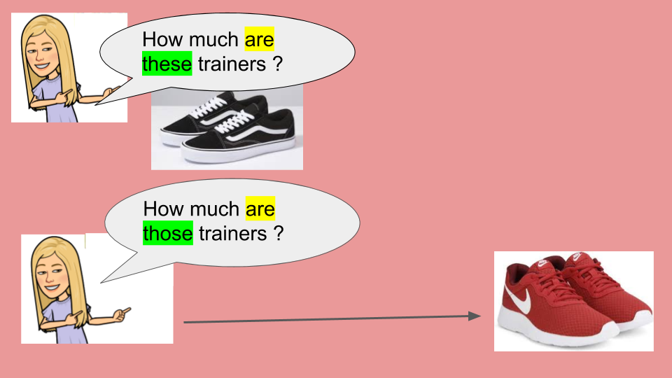
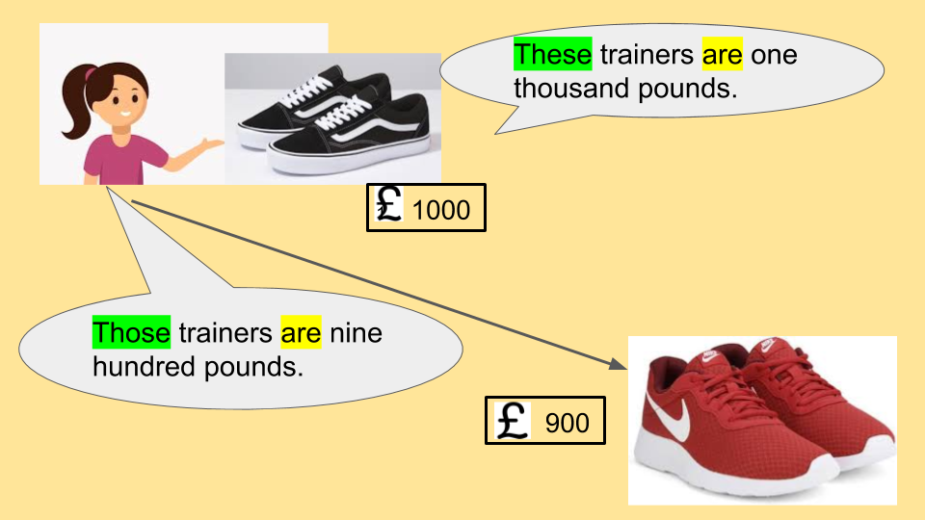

- Watch https://docs.google.com/presentation/d/1xmHi-OPBoxEjdPHM5NeZ7bmI2oB_wGnVm0EJjZ7I0zA/edit?usp=sharing
Pupil’s book pages 41 and 42 / Activity book pages 37 and 38

- Check your answers https://docs.google.com/presentation/d/15KbP82woy9ZJG2uaOc7vNeg9oX8tjdRLhl6rsqfnxeI/edit?usp=sharing

