“María, Madre del pueblo. Esperanza nuestra”
-400 años del hallazgo de la imagen de Ntra. Sra. del Valle-

4th “B” APRIL 21st AND 22nd
Código de classroom: hpjxl6f
QUERIDOS ALUMNOS:
esperando que se encuentren bien de salud tanto uds como sus familias, continuo acompañándolos en estas instancias de educación virtual SABEN QUE ANTE CUALQUIER DUDA PUEDEN ( POR PRIVADO) CONSULTAR POR EL AULA VIRTUAL DE CLASSROOM,( NO POR MAIL).
- Quiero aclarar que las actividades que voy asignando son parte de un proceso de evaluación cualitativa, es decir que se va a evaluar el proceso y cumplimiento de la sumatoria de actividades enviadas. Y PARA QUE TODOS PUEDAN REALIZARLAS EFECTIVAMENTE ESTOY ENVIANDO LAS PÁGINAS DE LOS LIBROS FOTOCOPIADOS PARA LOS QUE NO PUDIERON COMPRARLOS, DE NO TENER EL LIBRO DEBEN IMPRIMIR O COPIR LOS EJERCICIOS EN LA CARPETA.
- Se va a avisar luego del desarrollo de algún tema cuando haya un TP evaluativo, el mismo será resuelto con sus materiales de trabajo, libro diccionario, carpeta, web) y tendrá un tiempo límite para enviarlo AL IGUAL QUE LAS ACTIVIDADES QUE SE VAN PIDIENDO PARA ENTREGAR. Las instrucciones para los audios en caso de haber actividades de ese tipo está adjuntadas en el aula virtual de CLASSROOM

OBJETIVOS:
- Retomar y reforzar los tiempos Presente Simple y Pasado Simple del verbo TO BE y el resto de los verbos.
- Reconocer y aplicar vocabulario relacionado a la descripción de personalidad.
- Leer comprensivamente para distinguir la información correcta y asi resolver las oraciones (V/ F ) y responder preguntas.

CRITERIOS DE EVALUACIÓN:
- Comprensión Lectora
- Cumplimiento de consignas
- Cumplimiento de tareas en tiempo y forma

a)Do exercise 1, 3 and 4 from VOCABULARY (PAGE 10)
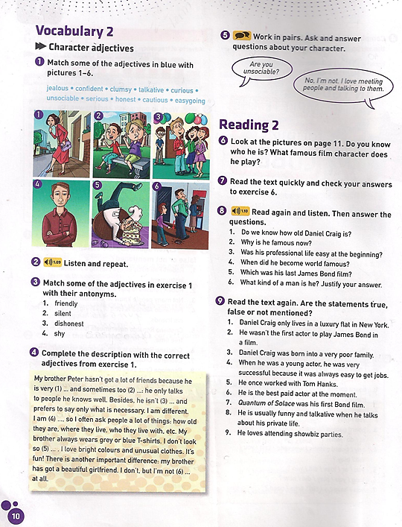

b) Now do the reading about JAMES BOND, (BRITAIN SPECIAL AGENT) (page 11).
c) AFTER READING THE TEXT…. Do Exercise 8 and 9 from ( READING 2 on page 10)
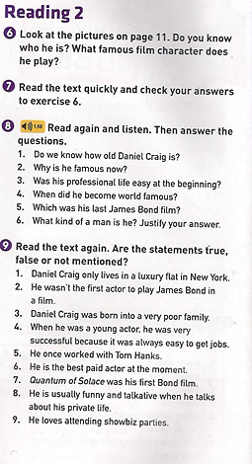

.

IMPORTANTE:
EJERCICIOS (1 Y 3 DE VOCABULARY)
EJERCICIOS (8 Y 9 DE READING)
DEBEN SER ENVIADOS PARA SU CORRECCION ENVIAR
SOLO POR CLARROOM
Espero sus trabajos, saludos!! Miss Alejandra
FECHA LÍMITE: MIERCOLES 29 DE ABRIL DE 2020

