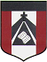
ESCUELA NUESTRA SEÑORA DEL VALLE
Queridos chicos y familias: Les recuerdo que el año próximo se continuará por un tiempo trabajando con el libro pedido este año. Por lo que es muy importante conservarlo.
Gracias por la colaboración y el esfuerzo realizado.
Los saluda con cariño Miss Marian

November 16th, 17th and 18th 5th grade

- Clothes : Play 1) https://wordwall.net/resource/4738922/clothes
2) https://wordwall.net/resource/4740142/clothes-sombras
3)https://wordwall.net/resource/4827689/memory-game-clothes
- Watch https://drive.google.com/file/d/1SYeCRmLzbahYS1Zan4RPQXT2Kw-WPP8c/view?usp=sharing

- Watch again and colour the clothes and accessories you see ( Volver a ver el video y colorear en la tabla la ropa que ves )

umbrella | t-shirt | dress | hat | sunglasses | gloves
shoes | uniform | socks | jacket | scarf | sandals
football boots | wallet | cap | swimsuit | tracksuit | sweatshirt
jeans | shorts | shirt | trainers | trousers | skirt

- Watch Part 1 ( Family ) https://www.loom.com/share/1b812cfb1bed4dc6920542b2951c3883

Part 2 ( Family and ordinal numbers)
https://www.loom.com/share/d71f9461c0bf4086b191f4875b3d9af3

- Family
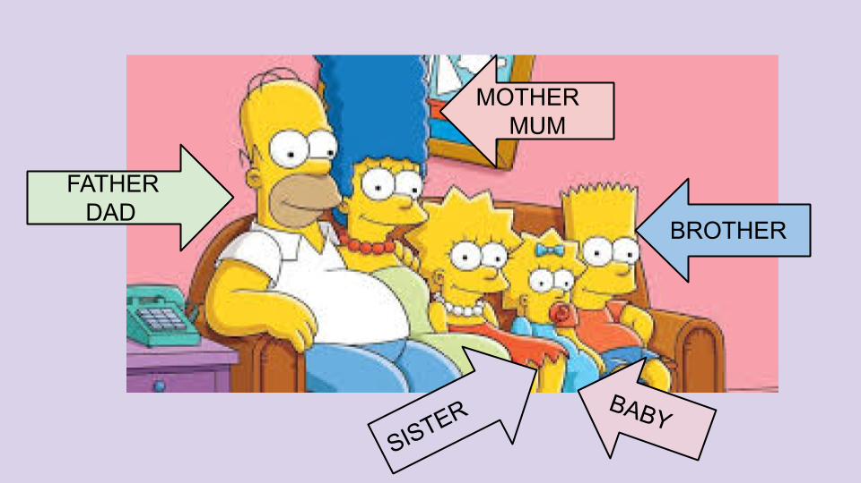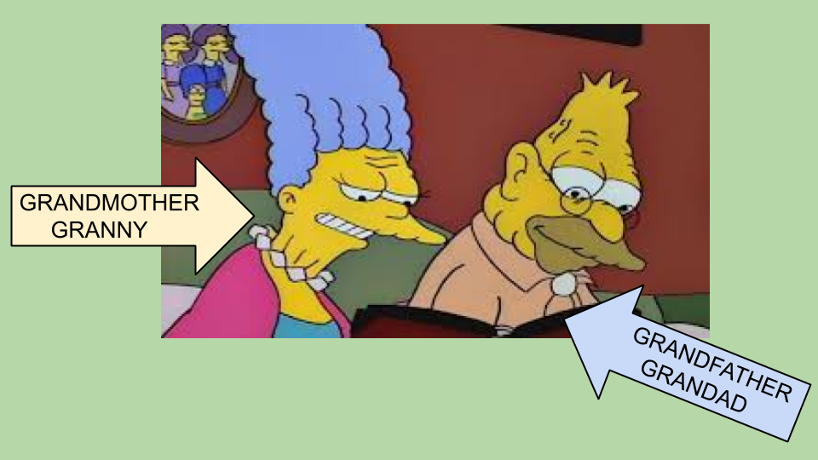
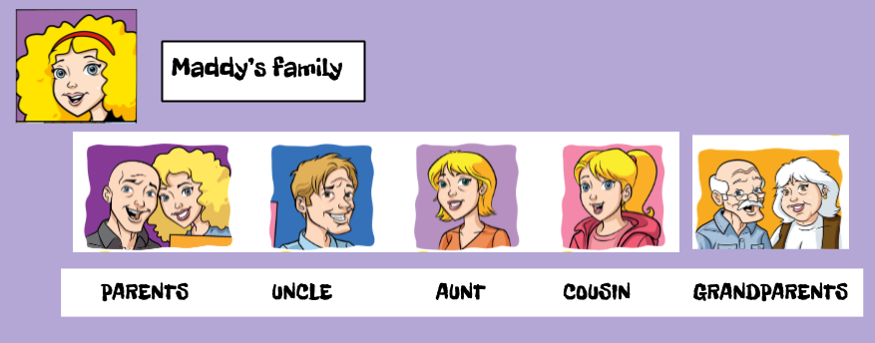

- Family :Play https://wordwall.net/resource/2774694/simpsons-family-find-match

- Complete :

aunt / uncle / mother / brother / grandfather / grandmother / father / sister / cousin

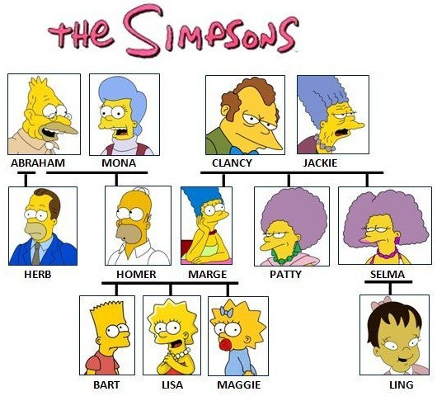
1. Lisa is Bart’s _____________

2. Bart is Lisa’s _____________

3. Linge is Bart’s ____________

4. Homer is Bart’s ___________

5. Marge is Bart’s ___________

6. Herb is Bart’s ____________

7. Patty is Bart’s ____________

8. Abraham is Bart’s _________

9. Mona is Bart’s ____________

- Watch https://docs.google.com/presentation/d/1bKdWxTJY9gKQjI0WdJ936GHUAYmMBIwnYGXVE3Ke5Jo/edit?usp=sharing
Pupil's book page 50 ( Exercises 3 and 4 ) / Activity book page 44

- Check your answers https://docs.google.com/presentation/d/1_pC4i_z1WF60cLEUgqB8IfCUP-3iBMw-nGMIUlB4kLI/edit?usp=sharing

- Ordinal numbers :

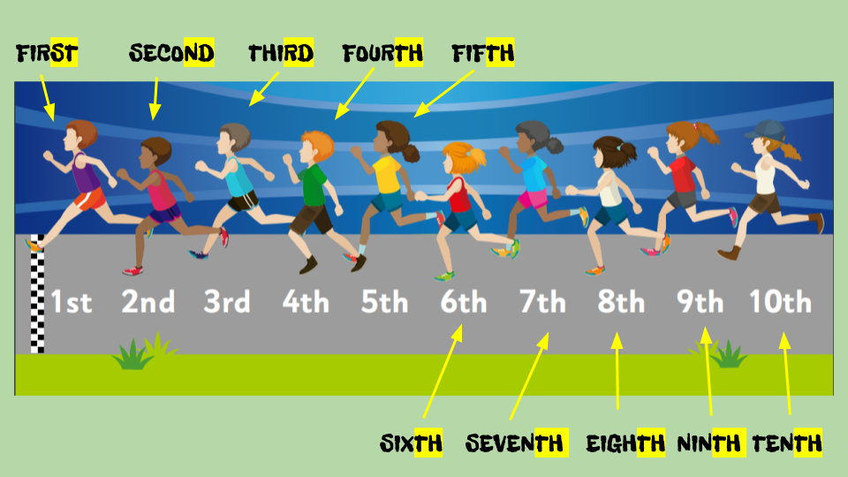

- Recordar al describir la ropa que estás usando decir primero el color…
I’m wearing a red t-shirt and blue shorts .
y cuando digo shorts, trousers, trainers, sunglasses, boots,etc no digo “a”
I’m wearing trousers, trainers and sunglasses … porque son palabras en plural.
¡Hermosos videos y fotos que me han mandado! ¡Los felicito !

Miss Marian

