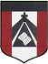
ESCUELA NUESTRA SEÑORA DEL VALLE

October 26th , 27th and 28th 3rd grade

Hello children ! How are you ? __________________________

- Revision Clothes: Watch https://youtu.be/PKOVLKo3Z9M

- Watch: Part 1 https://www.loom.com/share/03a39eba7f7a4c0d8389ff287ab4ef95
Part 2 https://www.loom.com/share/3279b75a666347218ea54c1e668f8b10?from_recorder=1

- Clothes: Play https://es.educaplay.com/recursos-educativos/7081978-clothes.html

- More Clothes
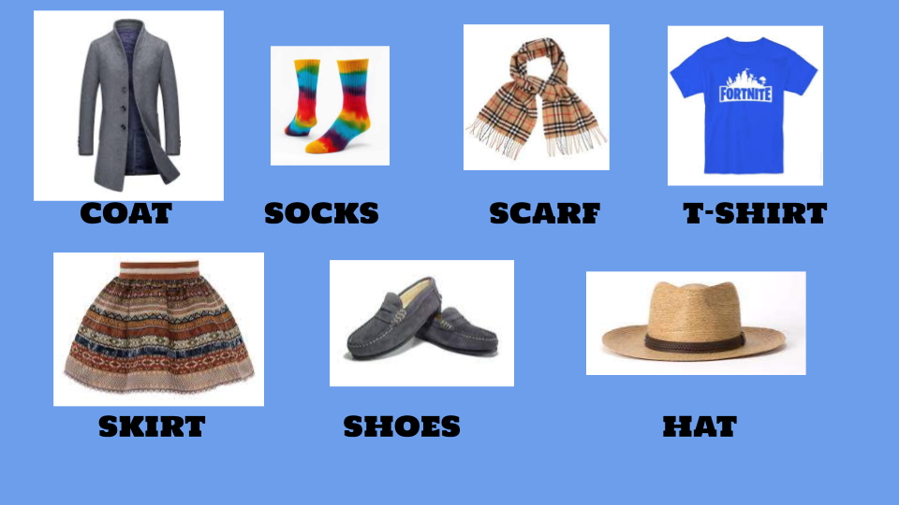

- What is he wearing ? What is she wearing ?
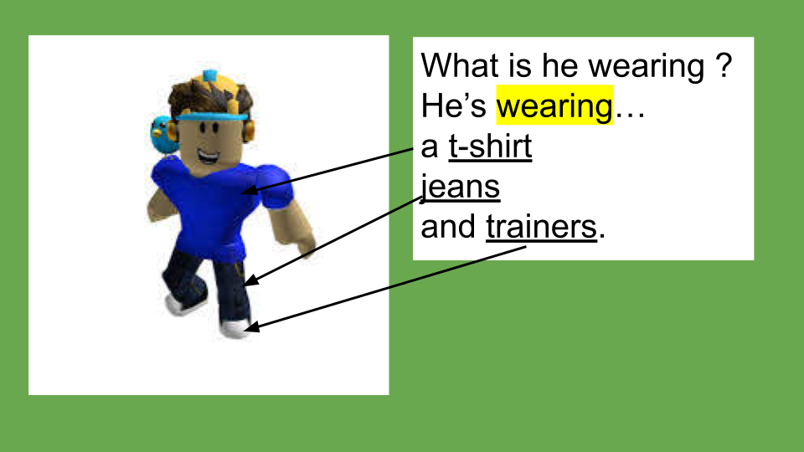
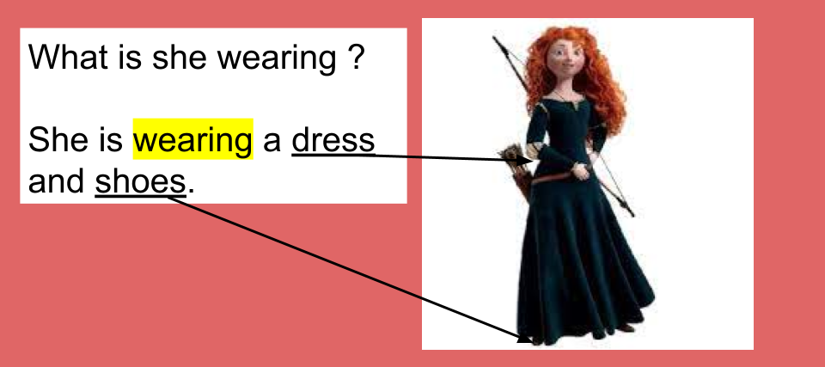

- Watch https://docs.google.com/presentation/d/1mfAVKmgJDFbY1F0FJjGSSaoBAcRIo-3e2cdqCsymwCI/edit?usp=sharing
Pupil’s book pages 44 and 45 / Activity book pages 38 and 39

- Check your answers https://docs.google.com/presentation/d/1AU0g3inR8dzdJ3sZceWbXhpzUiRfKarOW2loDzYosX4/edit?usp=sharing

- Look and write the names ( Leer la descripción y escribir el nombre )
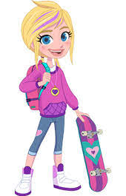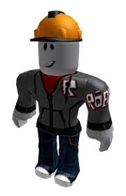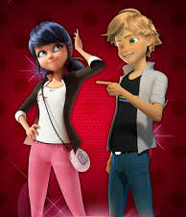
CAPTAIN AMERICA POLLY ROBLOX MARINETTE ADRIEN

- She’s wearing pink trousers, a white t-shirt and a black jacket. ____________
- He’s wearing a uniform. ____________________
- He’s wearing blue jeans, a black t-shirt and a grey shirt. _________________
- He’s wearing a yellow hat, a grey jacket, blue jeans and trainers. __________
- She’s wearing a pink sweatshirt, blue jeans and white trainers. ____________

Miss Marian

