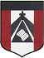
ESCUELA NUESTRA SEÑORA DEL VALLE
Queridos chicos y estimados padres:
Comenzamos otra semana con nuevos desafíos!
¡Gracias por el acompañamiento ! Un afectuoso saludo Miss Marian

June 8th, 9th and 10th 4th grade
- Animals: Watch https://youtu.be/1QV_dN-pSb4

- Play 1- http://www.carmenlu.com/first/vocabulary/weather1/animals1_2.htm

2-http://www.eflnet.com/vocab/dictionary/animalsquiz3.php

- Watch the presentation https://www.loom.com/share/88617c018ede4f4184b382828e4563e4

- More animals
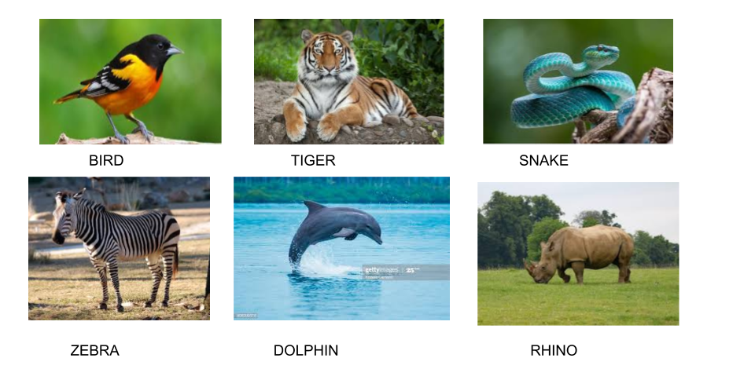

- What do animals eat?
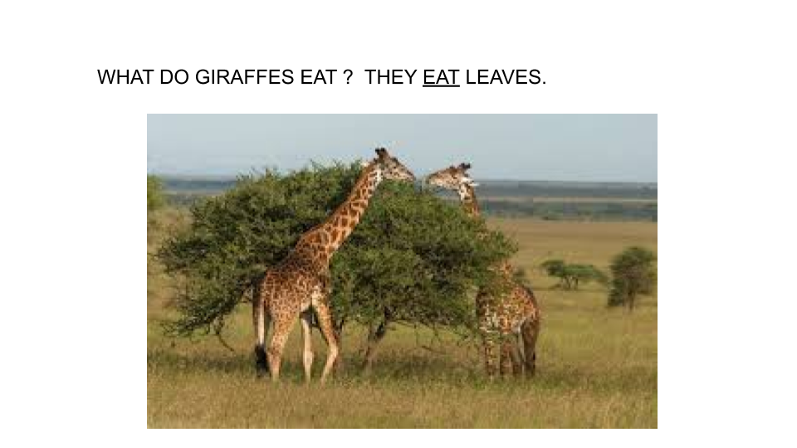
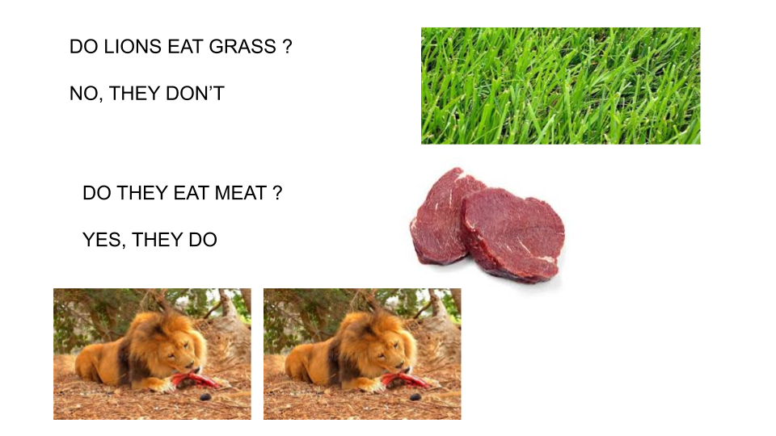
- Watch the presentation https://docs.google.com/presentation/d/17jLYLXWSstvFavrkJKMc-KzDurqVx-S7sPaXUgtNEDo/edit?usp=sharing
Pupil's book page 17 / Activity book page 13

- Choose the correct alternative

- Dolphins eat grass / fish / leaves.
- Zebras eat meat / fish / grass.
- Rhinos eat pizza / grass / fruit .
- Tigers eat meat / fruit / leaves .
- Snakes eat grass / leaves / meat .
- Birds eat spaghetti / insects / fish .

G) Now check your answers https://docs.google.com/presentation/d/1S9LkhtKbQ5N2GPfBOstObseWsGUzpeKQYjfuRi55NDA/edit?usp=sharing

