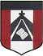
ESCUELA NUESTRA SEÑORA DEL VALLE

October 13th and 14th 3rd grade

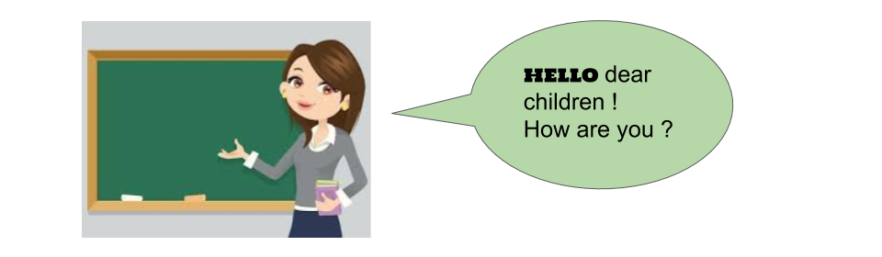

- Parts of the house :Play https://es.educaplay.com/recursos-educativos/6479308-my_house.html

- Parts of the house :Play https://es.educaplay.com/recursos-educativos/6769827-parts_of_the_house.html

- Parts of the house: Watch https://youtu.be/j2qKo5_cwdc

- Watch https://www.loom.com/share/907e727c257746c582630807cc65b904

- Watch https://docs.google.com/presentation/d/1Ic5NXVNCTT0UYo87q_tuXf17u_Ub0P-tfOvpm6oeCc8/edit?usp=sharing
Pupil’s book pages 40 and 41 / Activity book pages 34 and 35

- Check your answers: https://docs.google.com/presentation/d/1vv0B5-oRHkPSY9FOVohm-WPgnPyeHmP5ozQMfGqDJ-c/edit?usp=sharing

- Look at the picture and colour the correct alternative:

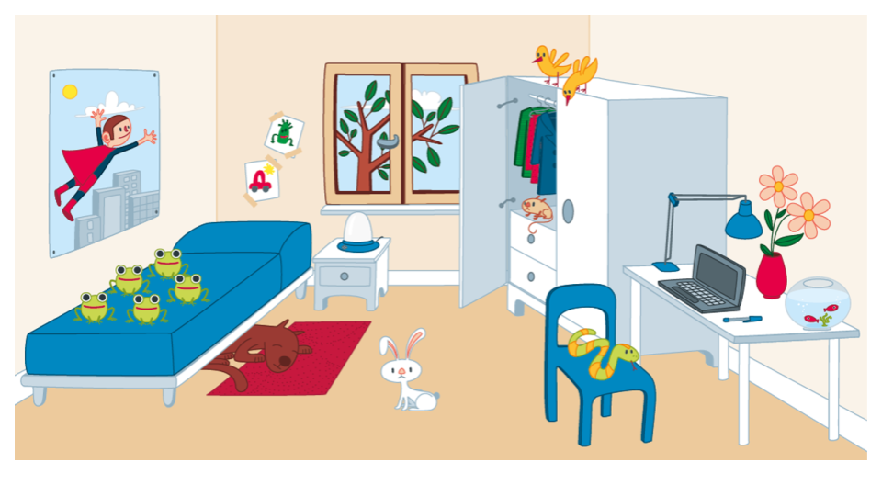

- It’s the kitchen / bathroom / bedroom.
- The snake is in / on / under the chair.
- The dog is under the table / wardrobe / bed.
- The mouse is in / on / under the wardrobe.
- There are four / five / six frogs on the bed.
- The computer is on / in / under the table.
- The birds are on the bed / chair / wardrobe.

Miss Marian

