ESCUELA NUESTRA SEÑORA DEL VALLE

Queridos chicos , estimadas familias: ¡Que tengan una hermosa semana!
Al entregar las tareas recordar escribir en el asunto :
Nombre,grado, división y fecha del trabajo. Muchas gracias.
Los saluda con afecto Miss Marian mfrontera@institutonsvallecba.edu.ar

September 7th, 8th and 9th 4th grade

Hello children ! __________
How are you ? ________________________
What’s the weather like today ? ___________________________

- Weather Play ! Click

- Weather Play ! Click

- What’s the weather like ? Click

- Let’s review Click

- Watch https://www.loom.com/share/e6a7571c98cc4217af81a72a01ca306e

- Watch https://docs.google.com/presentation/d/1adLE9ygbevn0TxOWruOeG5I5Q1cUHCaBG-ojgP_L7hI/edit?usp=sharing
Pupil’s book pages 30 and 31 / Activity book pages 26 and 27

- Check your answers https://docs.google.com/presentation/d/1aYtJVEWpuY8qKT-yLs7-YjeHJ_pA1YhWIrCzVVrldG4/edit?usp=sharing

- Answer:What’s the weather like ?

cold / sunny / windy / hot / snowy / cloudy / wet / stormy / rainy

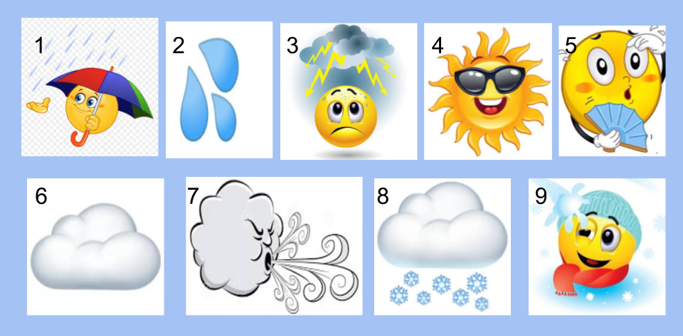

- It’s __________________ and 2. ___________________.
3. It’s ________________________.
4. It’s ______________________ and 5. _________________.
6. It’s _____________________.
7. It’s _____________________.
8. It’s _____________________ and 9. ___________________.

Miss Marian

