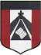
ESCUELA NUESTRA SEÑORA DEL VALLE
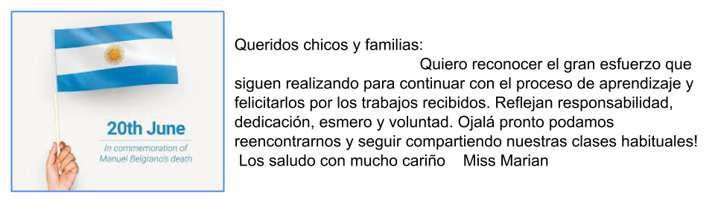
June 16th and 17th 4th Grade

- Animals : Play ! 1- http://www.koalatext.com/public/index.php/unitsv2/555
2-http://en.ver-taal.com/voc_animals9.htm

- Watch https://www.loom.com/share/0d8e32e2a7de4be58018313f49f764e0

- Watch https://docs.google.com/presentation/d/1oiFFgn07ZAK3_knxEWh0egKk1aFlyKu9A1xa7m2jXIk/edit?usp=sharing

- Now check your answers https://docs.google.com/presentation/d/1ZXNW7JnWd7_V29dkX3_Bho39lAANXf5JU8rKUmaOqG8/edit?usp=sharing

- More animals ( no hace falta dibujar los animales , sólo escribir el nombre para que quede en tu cuaderno )

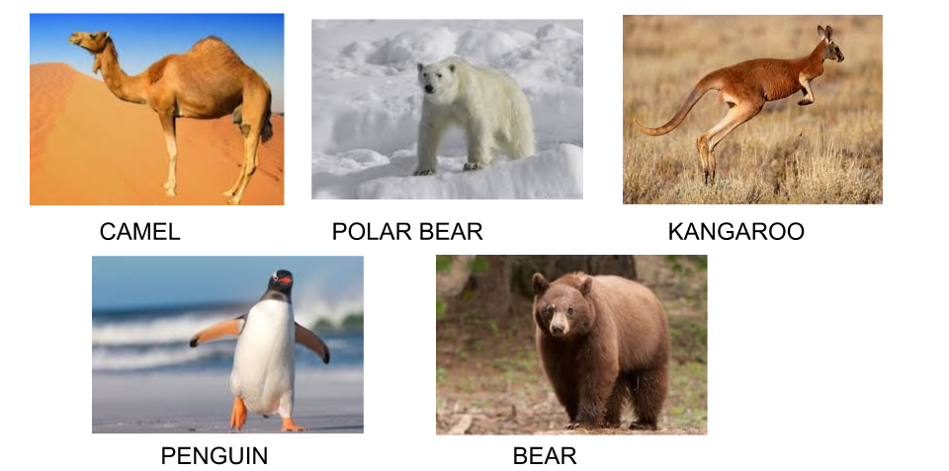
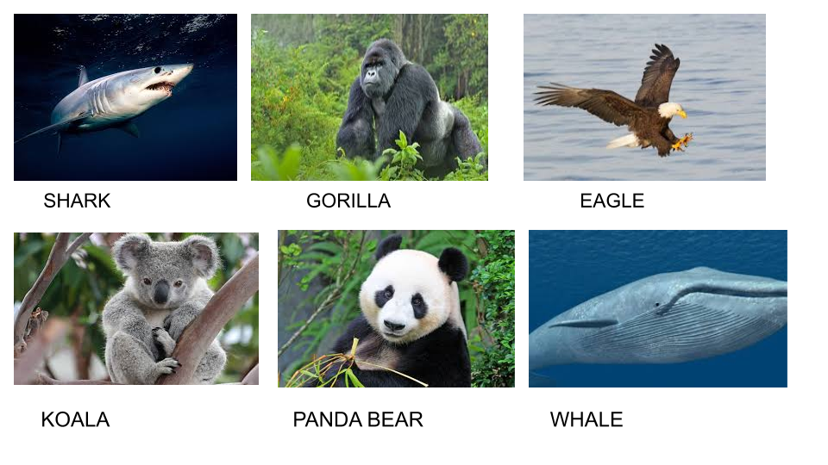
- Places
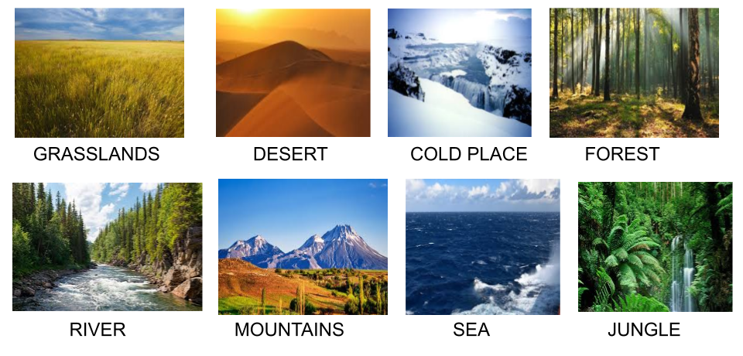
- Where do they live?
- What do they like doing?

- Circle the correct alternative

- Crocodiles live in the mountains / cold places / rivers.
- Camels live in the jungle / desert / sea.
- Whales live in the sea / rivers / forests.
- Kangaroos live in Argentina / Africa / Australia .
- Monkeys live in rivers / the jungle / cold places.

- Write the number of the correct answer

