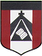
ESCUELA NUESTRA SEÑORA DEL VALLE

November 2nd, 3rd and 4th 5th grade

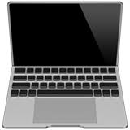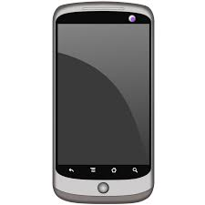

- Revision Clothes: Play 1-https://es.educaplay.com/recursos-educativos/7119777-clothes.html

2- https://es.educaplay.com/recursos-educativos/7119777-clothes.html

- Watch : Part 1 https://www.loom.com/share/e9b4918c831842d1acb57356d3a2c2ac?from_recorder=1
- Watch : Part 2 https://www.loom.com/share/714682e16567485389f54b90283bb18b?from_recorder=1
- Watch: Part 3 https://www.loom.com/share/8d75691fc2544f73b2f7eb2595dbb15c

- More clothes
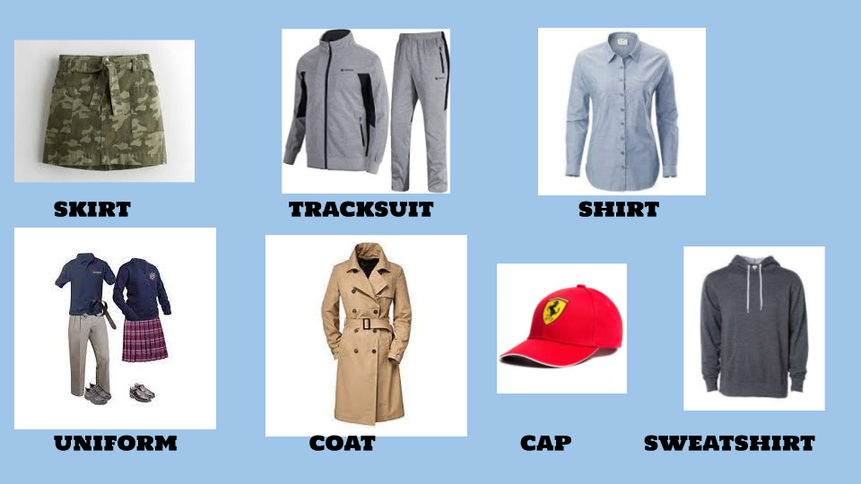
- Dialogue
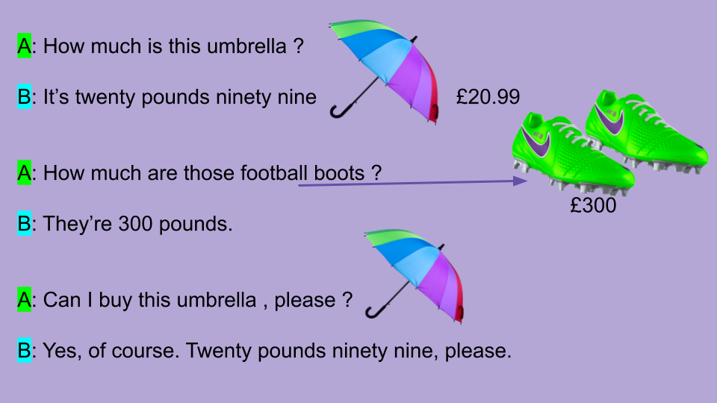

- Watch https://docs.google.com/presentation/d/1aseYjV9hEc2bK_CqUMnm3sc4pCfuKa8-NTwDyC6HOJY/edit?usp=sharing
Pupil’s book page 46 / Activity book pages 41 and 42

- Check your answers https://docs.google.com/presentation/d/1qu7B_j9Ap_wXSgyxYp6G7cJ3LZQ3pkq5EsCgsIgM9u4/edit?usp=sharing

- Write the clothes
football boots / t-shirt / hat / trousers / jeans / jumper / socks / shoes / boots / shorts

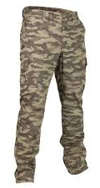 | 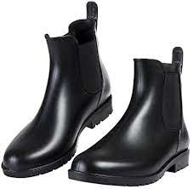 |  | 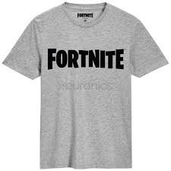 | 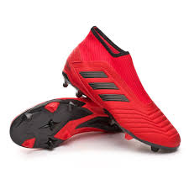
1 | 2 | 3 | 4 | 5
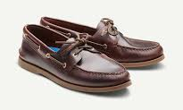 | 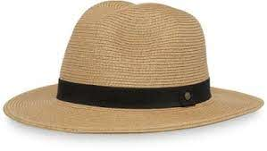 | 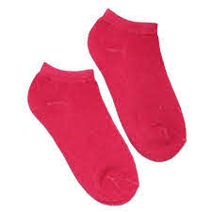 | 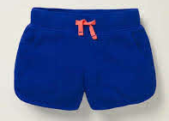 | 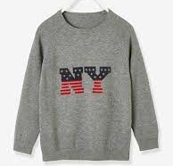
6 | 7 | 8 | 9 | 10
Miss Marian

