ESCUELA NUESTRA SEÑORA DEL VALLE

VIDEOCONFERENCE AUGUST 21 ^{st}

1-Complete with the correct information: Revisamos la actividad enviada…
CARDINAL ORDINAL
Twenty ………………………
…………………. Fifth
Eight ……………………..
…………………. Thirtieth
Twenty-one ………………………
………………… Twelfth

2-How do you write these dates?
-Martes 14 de enero: Tuesday 14th January
-Miércoles 19 de febrero
-Jueves 5 de marzo
-Lunes 6 de abril
-Viernes 1 de mayo
-Sábado 13 de junio

3-ACTIONS: Present Continuous. Describimos acciones que suceden al momento de hablar…
What is she doing? What are they doing?
What is he doing? What is she doing?
Are they swimming? Is she writing?
Are YOU walking?

4-Look at the picture and make sentences in the Present Continuous
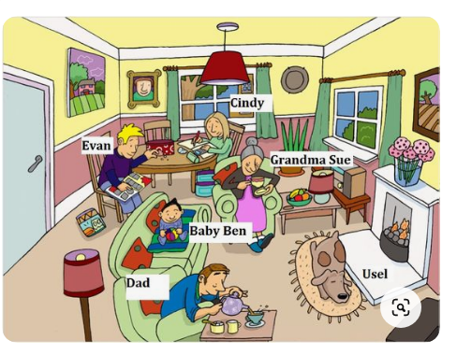
Cindy ……………………………………………….
Grandma sue ………………………………………….
Usel ……………………………………………
Dad ………………………………………………..
Baby Ben …………………………………………..

See you in our next videoconference on Friday August 28th
Evan …………………………………………………

