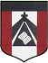
ESCUELA NUESTRA SEÑORA DEL VALLE

Queridos chicos y estimadas familias: ¡Buena semana para todos !
Hoy comenzamos la unidad 3 relacionada al tiempo libre.
¡Seguimos avanzando !
Recordar al mandar los trabajos, escribir en el Asunto :
Nombre y apellido / grado y división y fecha del trabajo.
Un saludo afectuoso Miss Marian mfrontera@institutonsvallecba.edu.ar

AUGUST HOMEWORK 2

August 10th, 11th and 12th 5th grade
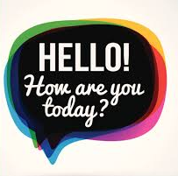

- Free time : Watch https://youtu.be/N1o4oOXLOZc

- Watch https://www.loom.com/share/3f60a73abb6b4bdd8f81e6653032bb93

- Revision : Free time
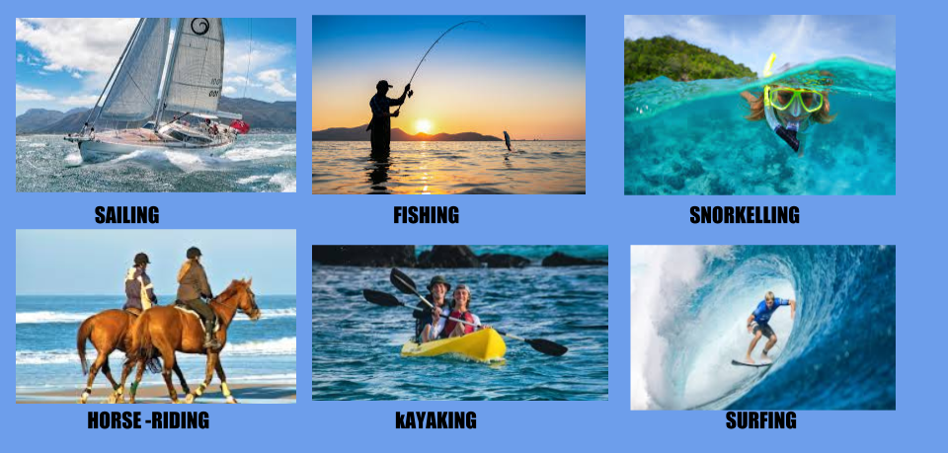

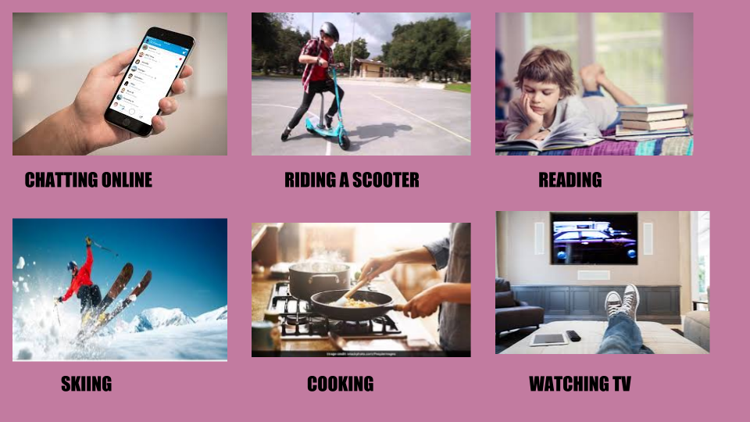
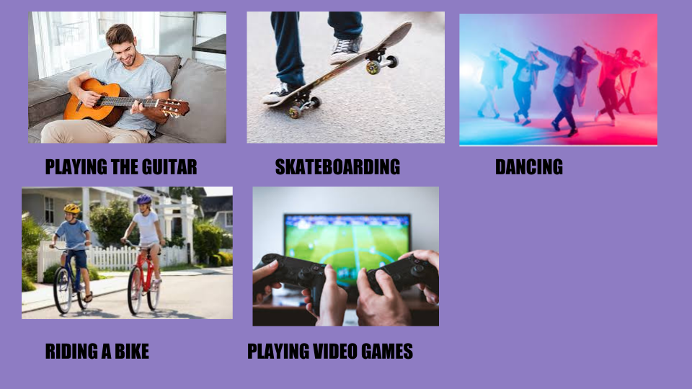

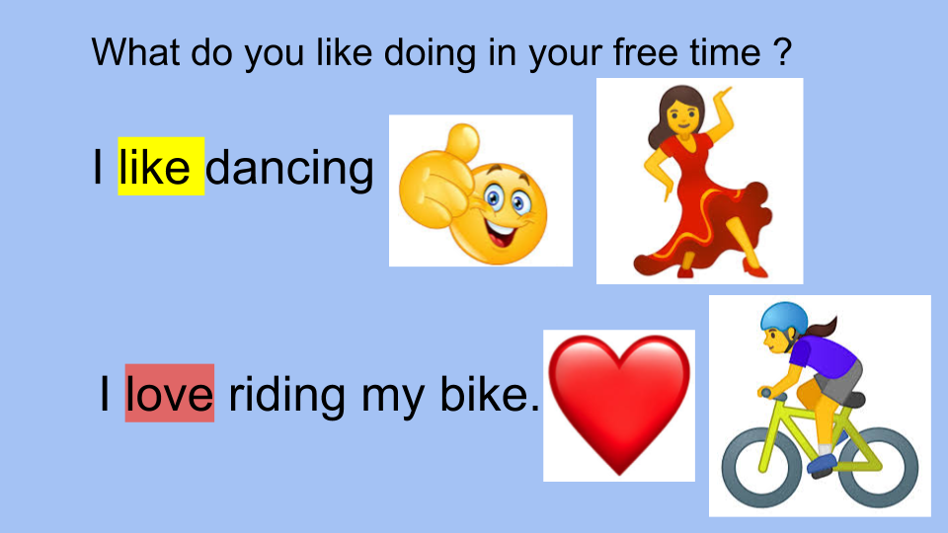
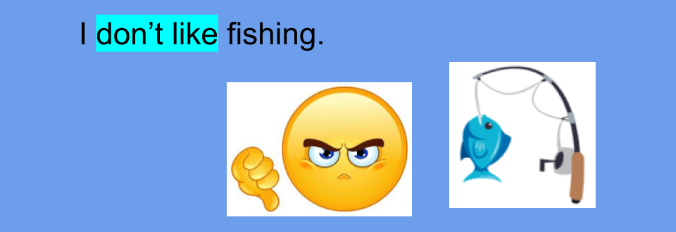

- Complete using: love / like / don’t like

- I _____________ playing football.
- I _____________ listening to music.
- I _____________ playing video games.
- I _____________ watching TV.
- I _____________ riding my bike.

- Unit 3 Free time

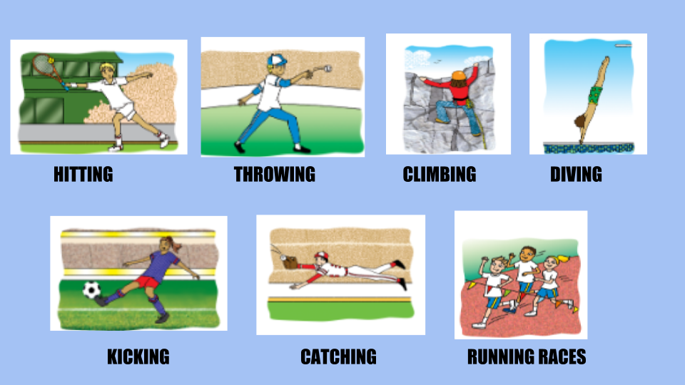

- What are you good at ?
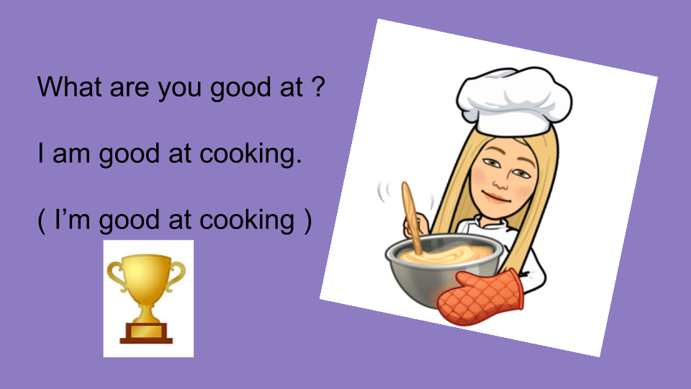
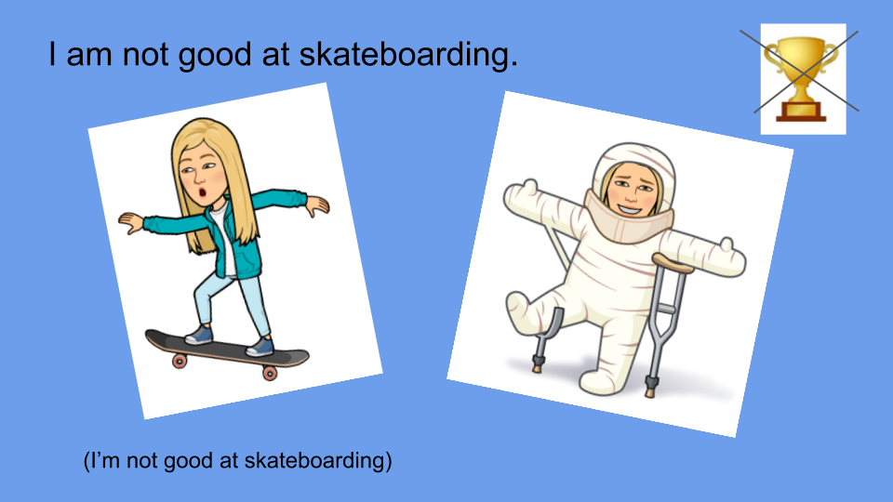

- Are you good at ?
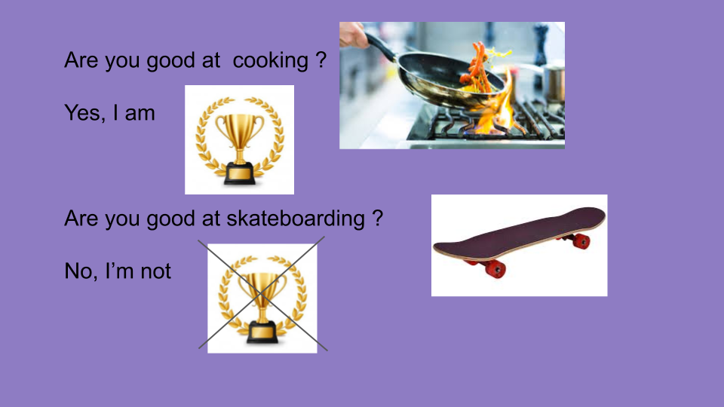

- Watch https://docs.google.com/presentation/d/1Ek6Uw1EMj7tazngTQeX7A9Uke4Ig5zOYMGbMfai79ac/edit?usp=sharing
Pupil’s book pages 22 and 23 / Activity book pages 20 and 21

- Watch Check your answers https://docs.google.com/presentation/d/1ZC2aMynllnLMME0nIksgkh8X3xiHkbEuY8p7ROfdrrM/edit?usp=sharing

- True or false ( Verdadero o falso de acuerdo a si sos bueno/a en estas cosas)

- I am good at kicking. __________
- I’m good at climbing. __________
- I’m good at diving. ____________
- I’m good at Mathematics. ____________
- I’m good at Art. _____________

- Answer about yourself : Yes, I am / No, I’m not

- Are you good at dancing? ________________
- Are you good at singing? _________________
- Are you good at running races? _____________
- Are you good at catching the ball ? _____________
- Are you good at playing tennis ? _______________

Take care of yourself !
Bye, bye!

