ESCUELA NUESTRA SEÑORA DEL VALLE
June 16th and 17th 5th Grade

- Routine : Watch https://youtu.be/qD1pnquN_DM
https://youtu.be/JwGnCIsLOpU

- The Time : Play !1- http://koalatext.com/public/index.php/unitsv2/734
2- http://koalatext.com/public/index.php/unitsv2/733

- Watch https://www.loom.com/share/b0ee40d82bd2459d9fc6aa3dfe535194

- Possessive case ( ‘s para indicar pertenencia)
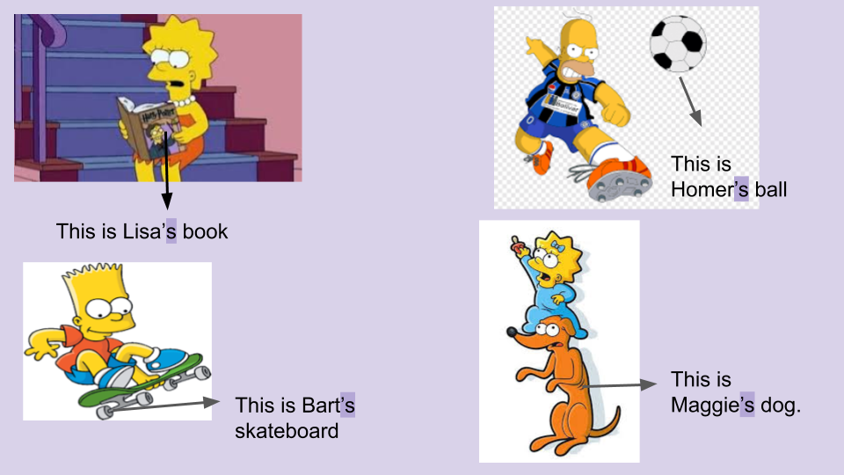
- Adverbs of frequency Watch https://youtu.be/WPTu1j6-B30

- Examples
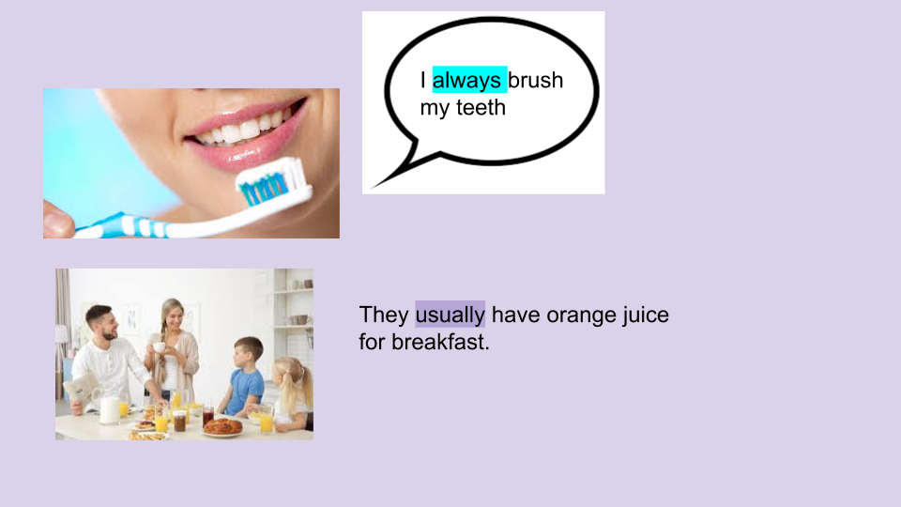
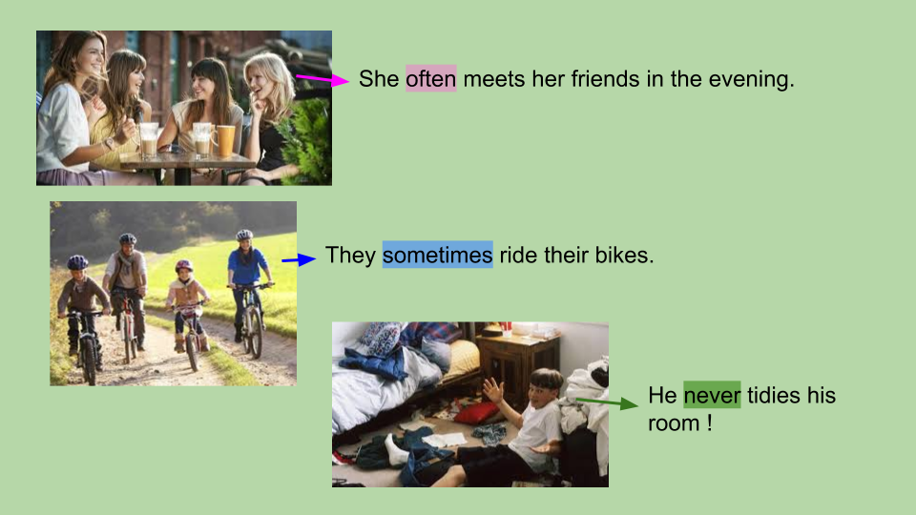
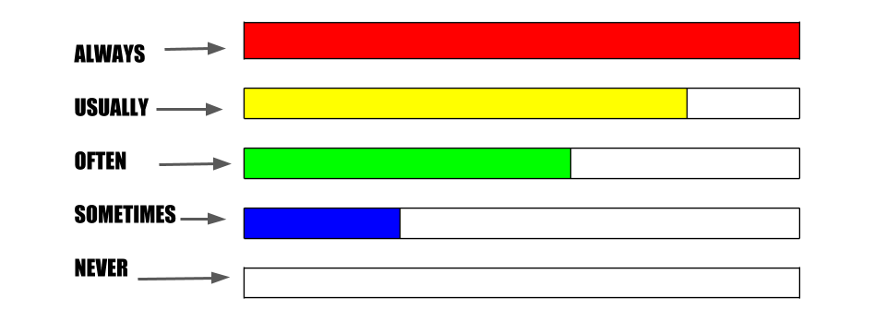
- Complete about yourself using always / usually / often / sometimes / never ( mirando el gráfico anterior completar sobre vos con qué frecuencia haces estas actividades )
- I ________________ make my bed.
- I ________________ brush my teeth.
- I ________________ watch TV.
- I ________________ chat online with my friends.
- I _______________ tidy my room.
- I _______________ do my homework.
- I _______________ play video games.
- I _______________ listen to music.
- I _______________ make Tik Tok videos.
- Watch https://docs.google.com/presentation/d/1Wvc1WSbAiaNKMTnsUmIbSq_37bOPEzPZIWnJcC8F3dI/edit?usp=sharing
Pupil's book page 16 / Activity book page 14

- Now check your answers https://docs.google.com/presentation/d/1SNu-tEEFTk7BhTDSYlzzqOTl-PIsib7_sNIYngPlNwQ/edit?usp=sharing

