ESCUELA NUESTRA SEÑORA DEL VALLE

October 5th,6thand 7th 3rd grade

Hello dear children ! ___________

How are you ? ________________

- Revision “ in/ on /under” Watch https://youtu.be/2SSjw9e-7ng

- Parts of the house: Watch https://youtu.be/nfBsIA5Lr0U

- There is / There are / in / on / under : Memory game https://matchthememory.com/thereis4thgradevuriloche

- Watch https://www.loom.com/share/99d4b7fb4b1d4e47b29240cd0ad55f42

- Revision In / on / under

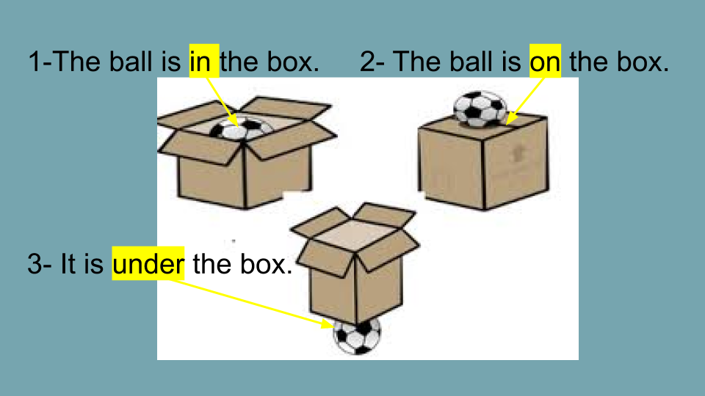

- SHAPES
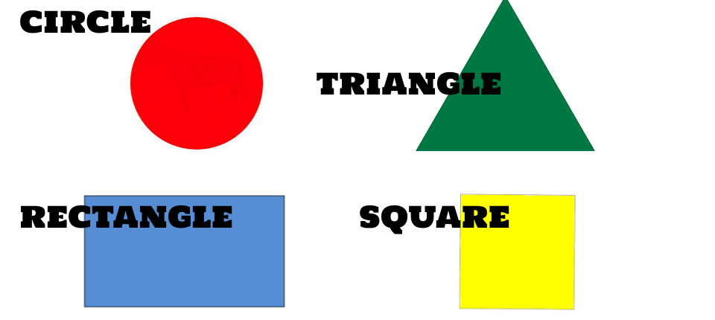
- Watch https://www.loom.com/share/4865958eb9a3403b8e8c47a59fcce3d8

- Watch https://docs.google.com/presentation/d/1iqbzYMPnyEvIXgF87UCzI6ZwSi3RYPUyyEhGs-WX9Po/edit?usp=sharing
Pupil’s book pages 38 and 39 / Activity book pages 32 and 33

- Now check your answers https://docs.google.com/presentation/d/1bi3Iw4IBua2YiXfO3YO9WjOuFmNtOs7pzNiBtQtvNhU/edit?usp=sharing

- Look at the picture and... ( mirando el dibujo escribí en el ejercicio 1 el animal y en el 2 si está “in-on-under” )

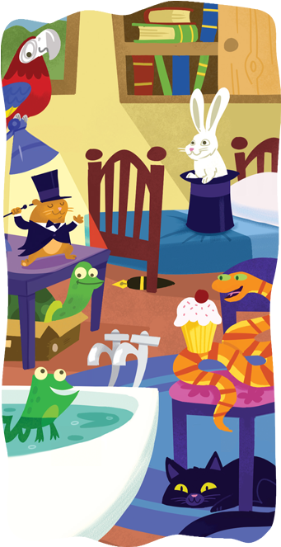

1- Write the animal ( escribí el animal )

- It is in the hat. _______________
- It’s on the lamp. _____________
- It’s under the chair. _____________
- It’s in the box. ____________

2- Complete using: in on under

- The hamster is ___________ the lamp.
- The frog is ___________ the bath.
- The snake is _____________ the chair.

