ESCUELA NUESTRA SEÑORA DEL VALLE

November 2nd, 3rd and 4th 4th grade

How are you ? ________________________
What’s the weather like today ? ____________________________

- Revision Jobs : Play https://es.educaplay.com/recursos-educativos/6540412-find_the_jobs.html

- Revision: What do you want to be ? https://youtu.be/eejZ4UvMqoc

- Watch https://www.loom.com/share/51503eeb7d38499290a8a5797b462c58?from_recorder=1

- More Jobs
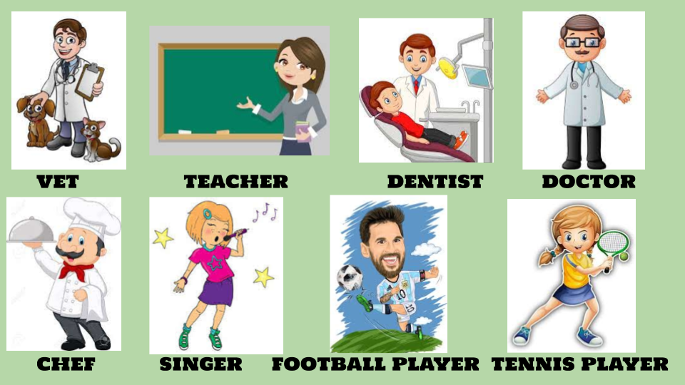

- What does he / she want to be ... ?

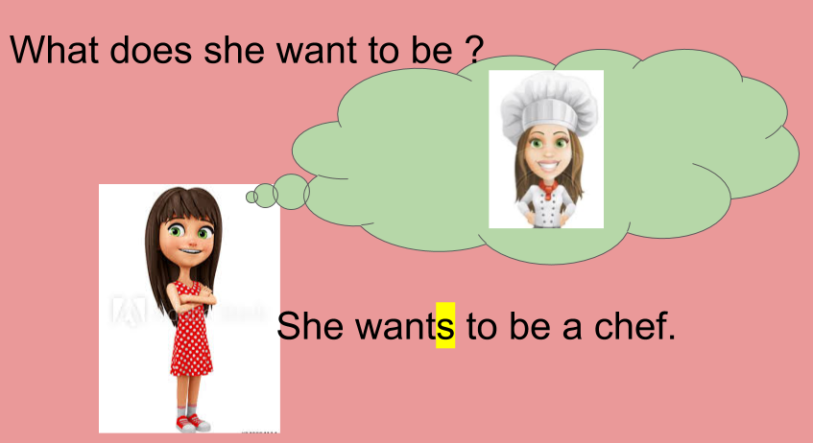
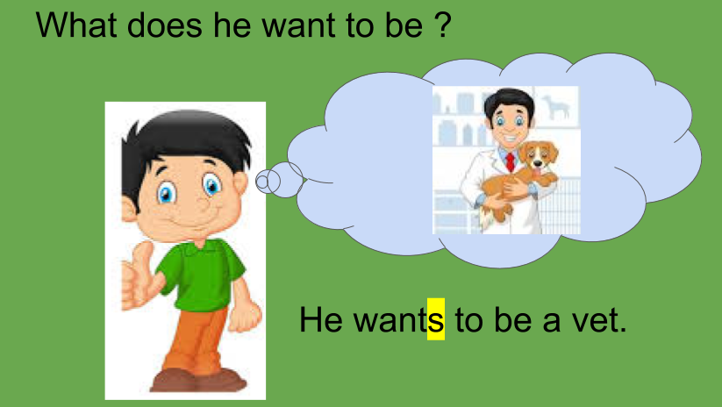

- Does he / she want to be a … ?

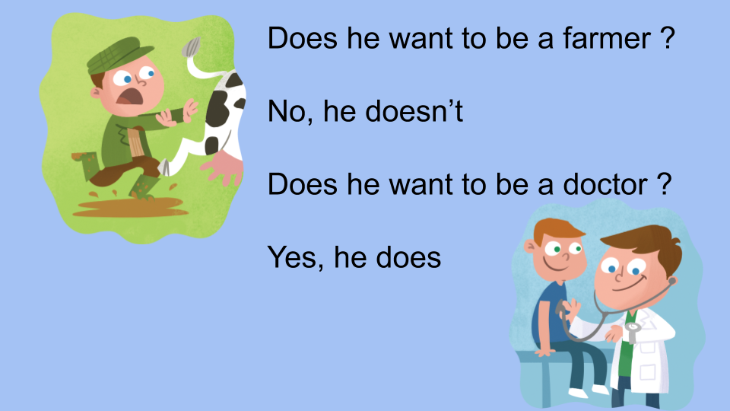
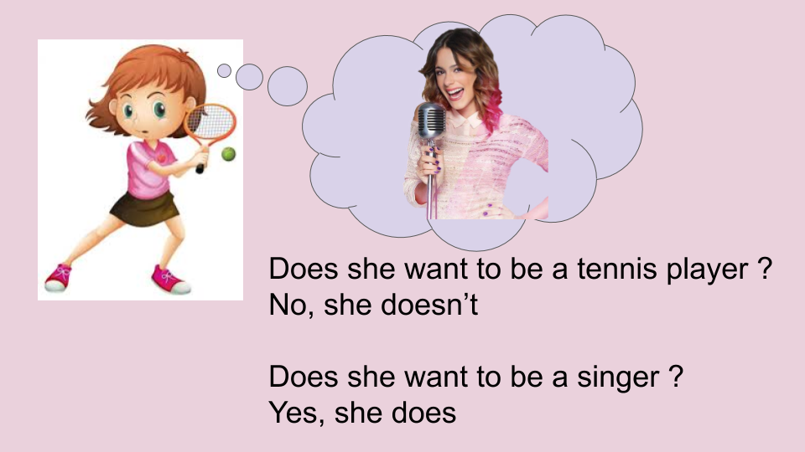
- Watch https://docs.google.com/presentation/d/1sPaj0fnhB15I2UeizRXQXHvfRcDR8LOvyAw7XERQ1cc/edit?usp=sharing
Pupil’s book pages 44 and 45 / Activity book pages 38 and 39

- Check your answers https://docs.google.com/presentation/d/1c43Y-bFsqgWsLa0nQROBFNcmNlwILt3AXiLAK-Yomqg/edit?usp=sharing

- What do you want to be ? I want to be a / an ...
Esta actividad es para hacer en una hoja aparte o en el cuaderno ,grande, para poder mostrar en el próximo Meet.Si no lo aprendimos averiguá como se dice lo que querés ser cuando crezcas y escribí :
I like ……
I want to be a / an … Podés dibujar, recortar y pegar, colorear y decorar.
También la tenés que mandar por mail.

What do you want to be ?
I like …
I want to be a ...

Miss Marian

