ESCUELA NUESTRA SEÑORA DEL VALLE
Queridos chicos y estimadas familias: ¡Continúan mis felicitaciones por los trabajos realizados! ¡Gracias ! ¡Seguimos trabajando ! Los saludo con cariño Miss Marian

June 22nd, 23rd and 24th 5th grade

- We are in Winter !
- The time : Watch https://youtu.be/Pht7dTlM0VA

- Routine: Play https://learnenglishkids.britishcouncil.org/es/node/17836
Look at the difference : wake up get up
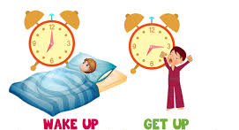

- Routine / Adverbs of frequency Watch https://youtu.be/VpESOerMY7I

- Watch https://www.loom.com/share/0e4fc5336e70480884167c24976ea76d

- Do you… ? Yes, I do / No, I don’t
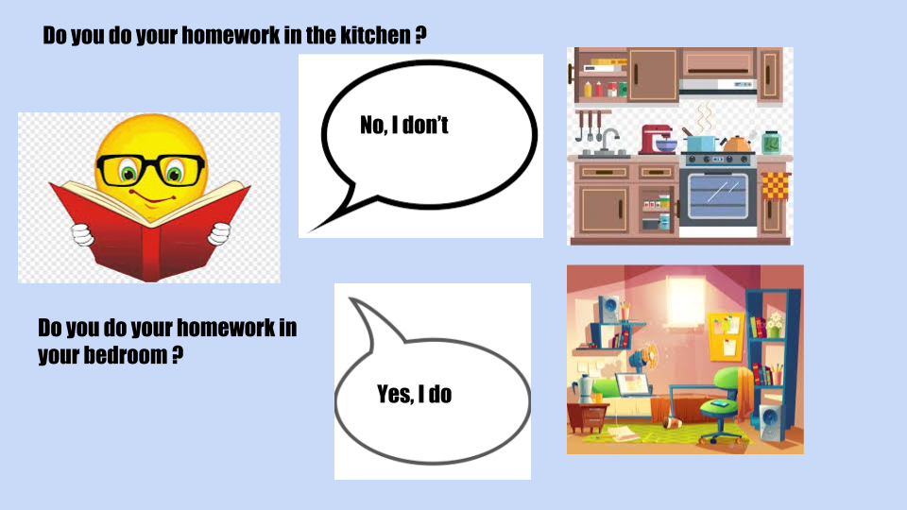

- Answer : Yes, I do / No, I don't

- Do you make your bed every day ? _______________________
- Do you have coffee for breakfast ? ______________________
- Do you do your homework in the living room ? __________________
- Do you always brush your teeth ? ________________________
- Do you play video games in the afternoon ? __________________
- Do you usually listen to music ? ______________________

- What time is it ? Look and circle the correct alternative:

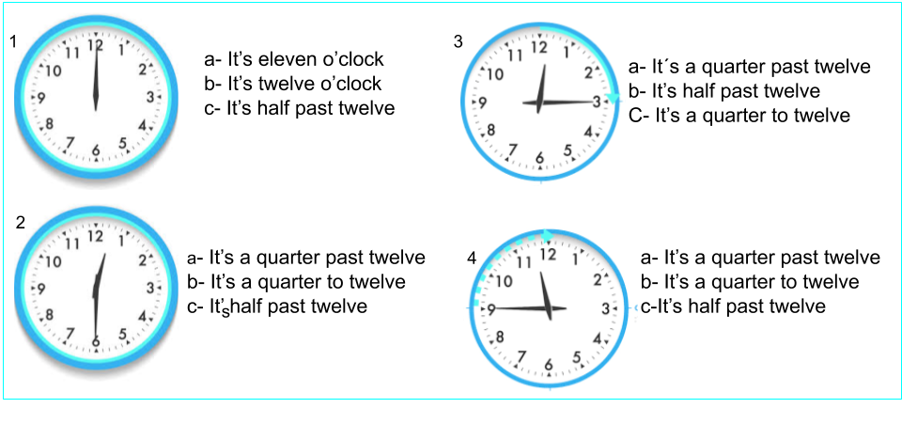
- Watch https://docs.google.com/presentation/d/1sdvdJG-PboKgZhlJDs2c69C3z_hsqzA8PMTx2t4uJZw/edit?usp=sharing
Pupil’s book pages 17 and 18 / Activity book pages 15 and 16

- Now check your answers https://docs.google.com/presentation/d/1sdvdJG-PboKgZhlJDs2c69C3z_hsqzA8PMTx2t4uJZw/edit?usp=sharing

