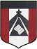
ESCUELA NUESTRA SEÑORA DEL VALLE

Queridos chicos y estimadas familias: Ojalá hayan disfrutado del merecido descanso para empezar con energías renovadas esta nueva etapa.
Recuerden mandar por mail los trabajos colocando en el asunto:
Nombre y apellido / Grado y división / Fecha del trabajo
A quienes hayan cumplido años durante las vacaciones les mando un fuerte abrazo , espero que hayan disfrutado mucho su día!
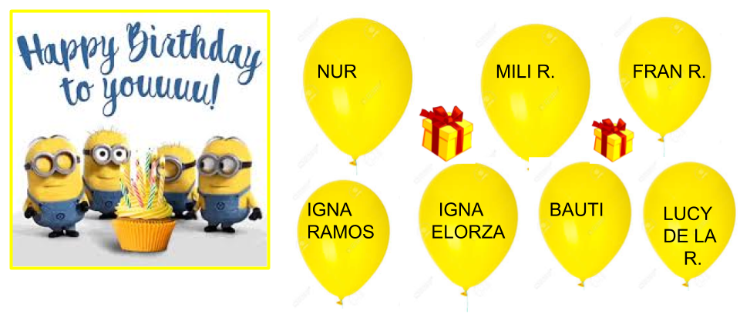Los saluda con cariño Miss Marian mfrontera@institutonsvallecba.edu.ar

AUGUST HOMEWORK 1

August 3rd, 4th and 5th 4th grade

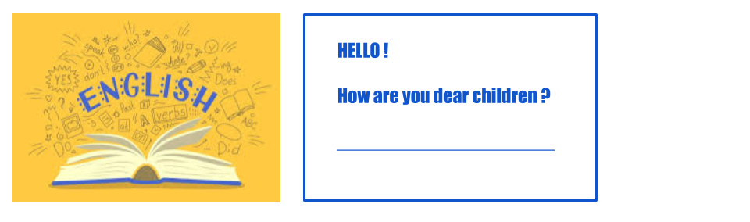

- Animals: Play https://matchthememory.com/jungle
- Zoo animals: click on the dice ( hacer click en el dado en el juego ) https://www.eslgamesplus.com/zoo-animals-vocabulary-esl-interactive-board-game/

- Watch https://www.loom.com/share/4f56326ffe3d4465ba735e4038e626af

- Body
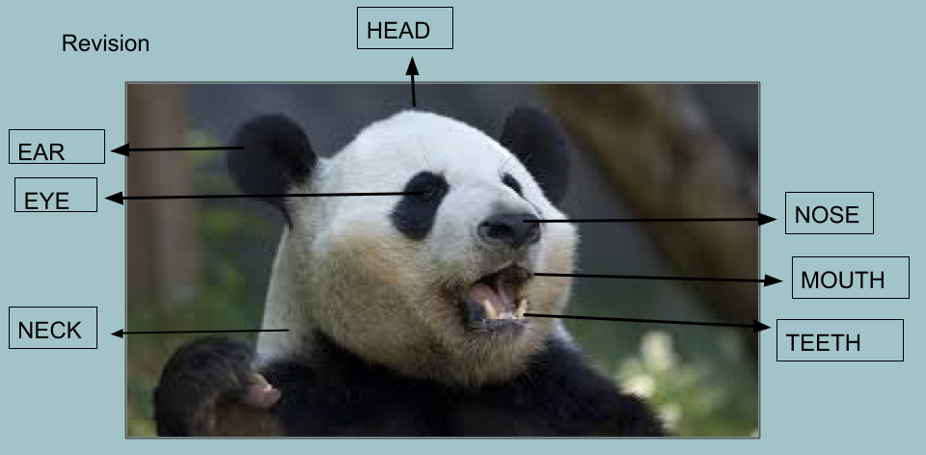
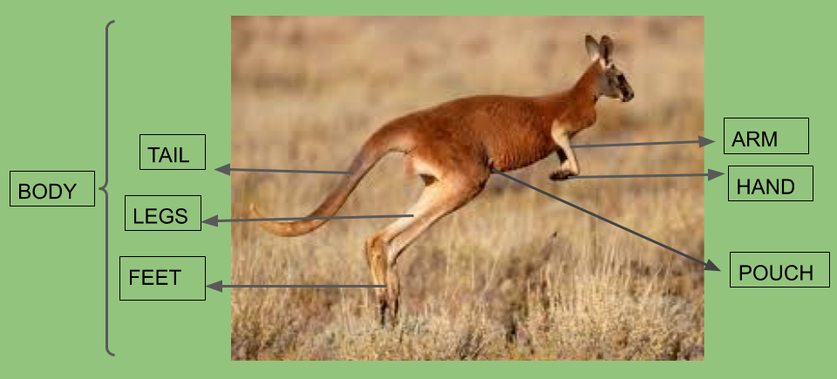
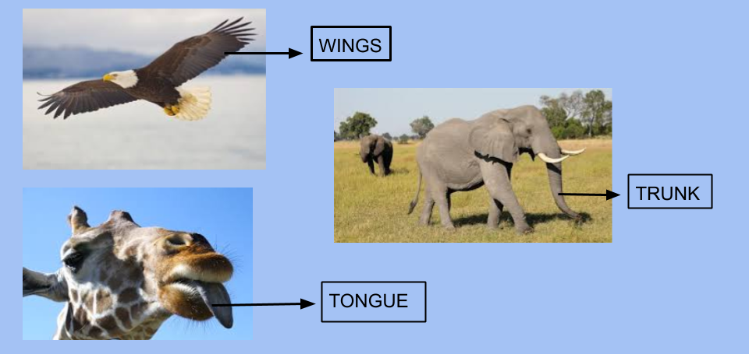
- HAVE GOT
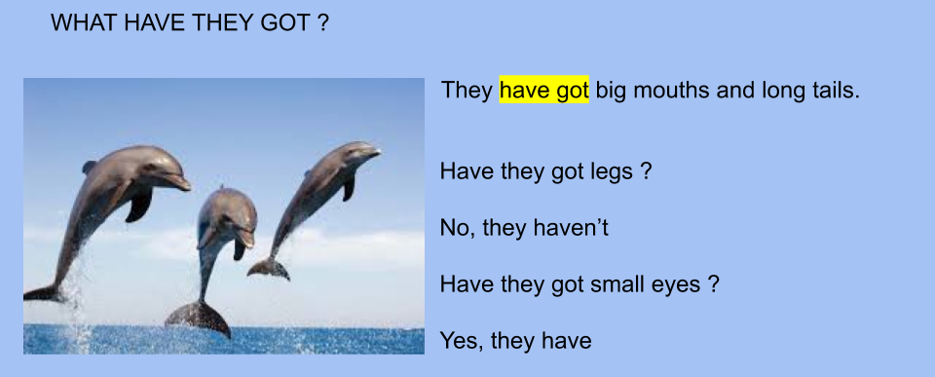

- Watch https://docs.google.com/presentation/d/1evapWDDUpqWTZ2jsZ5QzumDjO_evA4NiEaMkO39Hz4s/edit?usp=sharing Pupil’s b p 21- 22/ Activ.b p 17-18

- Now check your answers https://docs.google.com/presentation/d/1Dlk62m7pd0OPwrwB3MeJ8nSu_zQ8fznCwe0Uq1Hul_I/edit?usp=sharing

- Circle the correct alternative :
- Snakes have / haven’t got legs.
- Elephants have got long / short trunks.
- Giraffes have got long ears / wings / necks.
- Eagles have got four legs / wings / long tongues
- Koalas have got pouches / long tails / wings.

- Read and write the animal monkeys lizards dolphins elephants koalas
parrots kangaroos

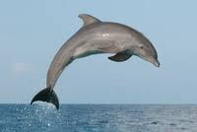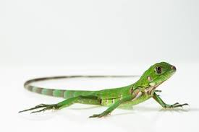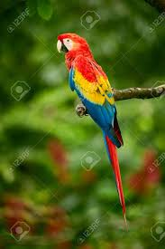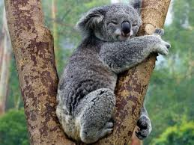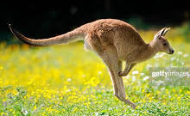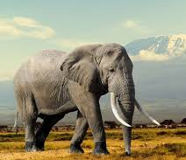
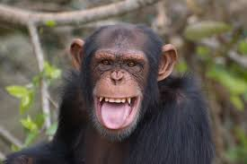

- They are big and grey. They live in grasslands. They eat fruit. leaves and grass. They have got big ears and long trunks. They are ______________
- They are red, yellow and blue. They have got feathers and wings. They’ve got two legs.They can fly. They are ______________________.
- They are grey. They have got long tails. They haven’t got legs. They live in the sea. They like swimming. They are _____________________.
- They are grey. They eat leaves. They live in Australia. They can climb but they can’t fly. They like sleeping. They are _____________________.
- They are brown. They have got long tails, pouches and big feet. They eat leaves. They can jump. They live in Australia. They are _____________
- They are dark brown. They eat fruit. They live in the jungle. They can climb but they can’t ski! They love bananas! They are _________________.
- They are green. They are small. They have got four legs and long tails. They eat insects.They are ______________________

Bye, bye !

