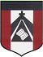
“María, Madre del pueblo. Esperanza nuestra”
-400 años del hallazgo de la imagen de Ntra. Sra. del Valle-

HI DEAR STUDENTS! HOW ARE YOU?
REMEMBER THAT YOU CAN HAVE ACCESS TO OUR VIRTUAL “GOOGLE CLASSROOM” WITH THIS CODE: 7hbws2f
SOME OF YOU HAVE ALREADY REGISTERED VISITS THERE. PLEASE, START ANSWERING THE HOMEWORK THERE, IN THE PLATFORM OF GOOGLE CLASSROOM SO THAT IT’S EASIER FOR ALL OF US. THANK YOU!

OBJECTIVES OF THIS CLASS:
- TO REVIEW THE GERUNDS IN FUNNY CONTEXTS
- TO LEARN HOW TO USE A NEW “APP”
- TO ASK AND ANSWER QUESTIONS USING THE GERUNDS
DEADLINE TO SHARE THE MEMES: THURSDAY, APRIL 30TH
ACTIVITIES:

- THIS TIME WE WILL BECOME MORE CREATIVE!
WE WILL MAKE “MEME CARDS” USING THE GERUNDS (“ING” FORMS) WE LEARNT.
YOU INVENT THEM, YOU SHARE THEM TO YOUR CLASSMATES, WE ALL LAUGH!
DO YOU KNOW HOW TO CREATE “MEMES”? IN YOUR CELLPHONES OR COMPUTERS, YOU WILL DOWNLOAD THE APPLICATION: “MEME CREATOR” (THERE ARE OTHER APPS TO DO THIS, CHOOSE THE ONE YOU LIIKE BEST). IT’S EASY! TRY!

HERE ARE SOME EXAMPLES OF SECONDARY STUDENTS WORKING WITH “MEMES”.

- IN YOUR FOLDERS, ANSWER THE QUESTIONS. (YOU CAN PRINT THE COPY IF YOU WANT )
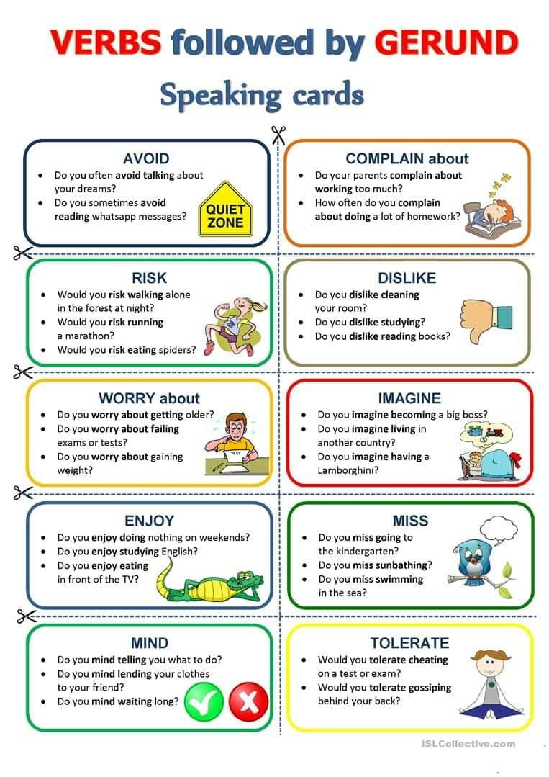
GOOD LUCK AND BE CREATIVE!
SEE YOU SOON

