ESCUELA NUESTRA SEÑORA DEL VALLE
4th grade
September 28th and 29th

Hello dear children ! _________________________
How are you ? _____________________________
What’s the weather like today ? ____________________

- Revision : Days. Play https://matchthememory.com/daysoftheweek15

- Revision: The time … It’s ...o’clock Watch https://youtu.be/K5q65e_E-os

- Watch https://www.loom.com/share/e0fc60d33bc646fe9784ce130cef2650

- Watch https://www.loom.com/share/3c508881ed0644119c5da62fee83c4d8

- Watch : Half past https://youtu.be/CFswaCX5mAA

- Half past ...

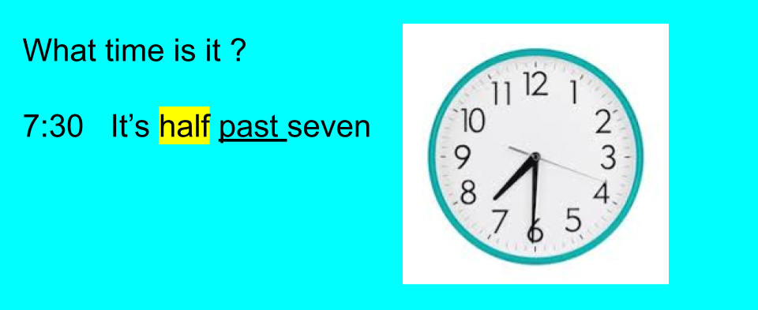

- What do you do on …?

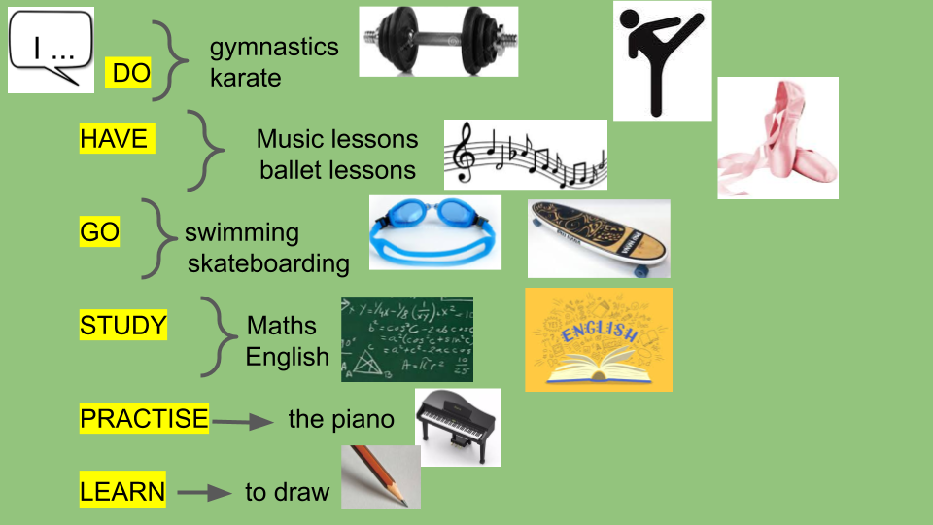

- What time do you …?

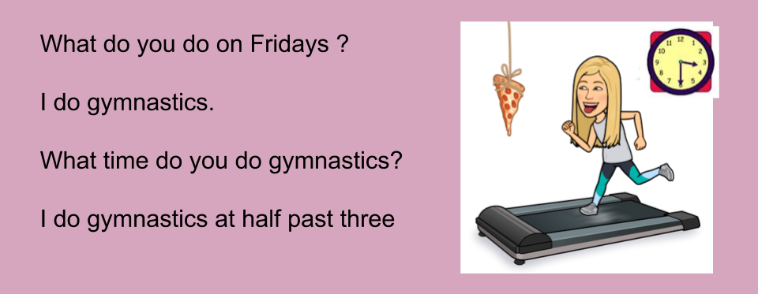

- Watch https://docs.google.com/presentation/d/10pgP2Vgy1SopfX7pxhC96mjxiYSTPJNc5bzBmQgI7qE/edit?usp=sharing
Pupil’s book page 35 / Activity book page 29

- Check your answers https://docs.google.com/presentation/d/1G6NXTnqhCln0bExv2DHtrebgyMadAMO-XsWTZj1MKZ8/edit?usp=sharing

- True or false ? ( sobre vos mismo )

- I do karate. __________
- I have ballet lessons. ____________
- I have Music lessons. ___________
- I study English . ________________
- I go skateboarding ._____________
- I practise the piano. ______________
- I do gymnastics. ____________
- I study Maths. _______________
- I learn to draw ______________

- What time is it ?

- 2: 30 It’s half past two.
- 4:30 ___________________________
- 7:30 ___________________________
- 10:30 __________________________
- 1:30 ___________________________

Miss Marian

