ESCUELA NUESTRA SEÑORA DEL VALLE

Queridos chicos y estimadas familias: ¡Continúan mis felicitaciones por los trabajos realizados! ¡Gracias ! ¡Seguimos trabajando ! Los saludo con cariño Miss Marian

June 22nd, 23rd and 24th 4th grade

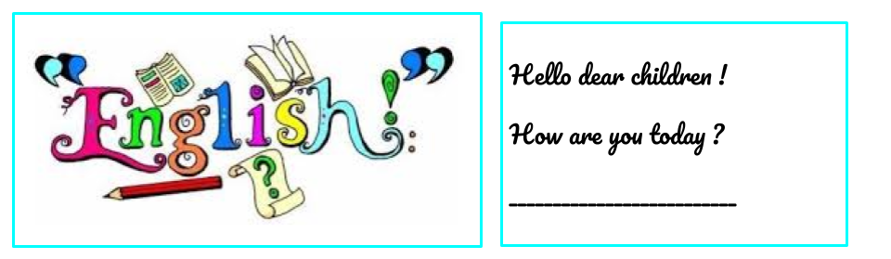

- We are in Winter !
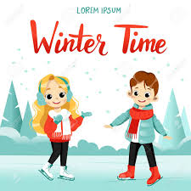
- Animals: Play http://users.skynet.be/providence/vocabulaire/anglais/zoo/zoo1.htm

- Watch https://www.loom.com/share/d0c910ffc98c48b68dc42c46b9fd90f3

- Watch https://docs.google.com/presentation/d/1CNROFKt00ySaN3ggDrsohNWPTvMC--NWsO2jH-HV1zg/edit?usp=sharing
Pupil’s book pages 19 and 20 / Activity book pages 15 and 16

- Now check your answers https://docs.google.com/presentation/d/1fw3fcZ1rgwzYpEu_nrfvc0MPcFQGgbBly2vBx5AVV6g/edit?usp=sharing

- Actions

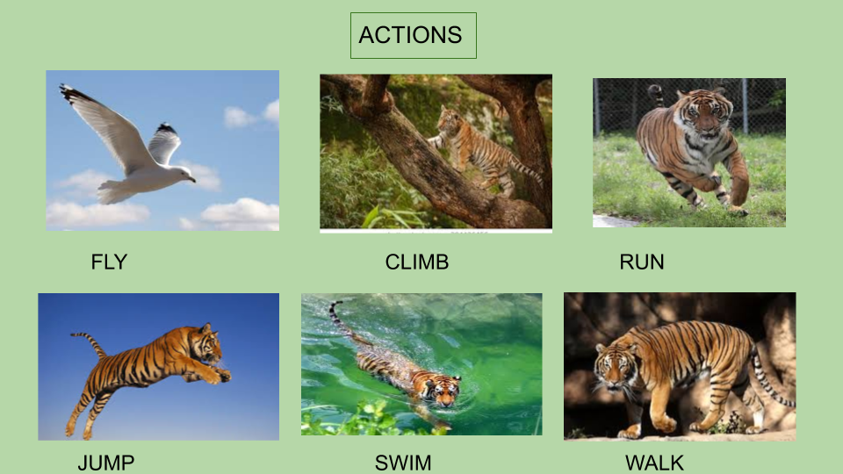

- What can they do ?

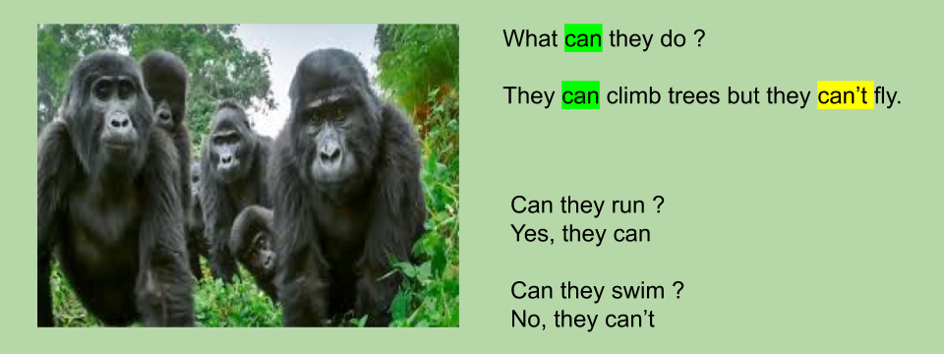

- Complete the paragraph using

eating / grey / climb / rhinos / grasslands / run / leaves /

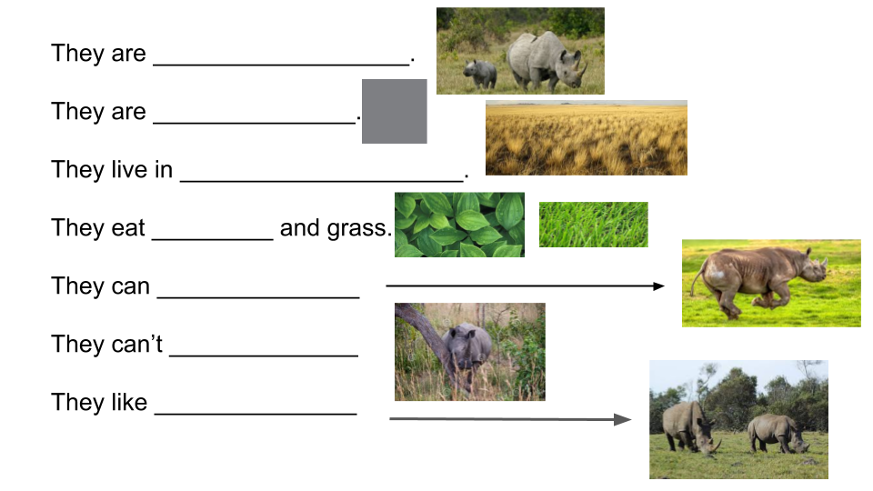
- Read the sentences and write

- Polar bears are black. _______________
- Panda bears eat leaves. _____________
- Kangaroos can jump . ______________
- Eagles can swim. _______________
- Hippos live in rivers. ___________
- Koalas like sleeping. ___________

